*Abdallah Tourbah*

  

***Intro to machine learning: final project***

***Dr Abbas Rammal***

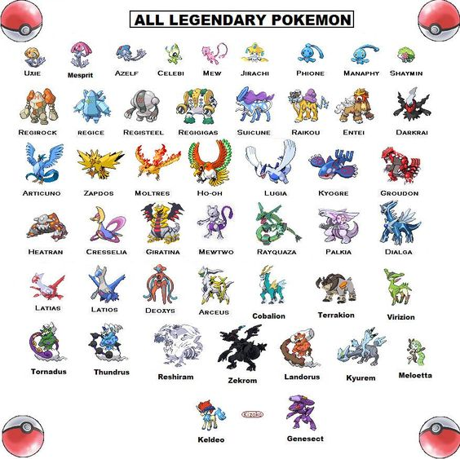

1. Importing libraries

we started by importing libraries, we imported pandas library for data manipulation and analysis, then imported numpy for numerical operations, matplotlib and seaborn libraries for data visualization. We also imported scipy.stats for statistical functions, MinMaxScaler from sklearn.preprocessing for feature scaling and finally imported train_test_split from sklearn.model_selection for splitting the dataset into training and testing sets and warnings to handle errors. Then we defined the headers column containing all the features to specify the columns names for our dataset. Then we specified the path to our data which is more than 1000 data and to load our dataset we used pandas function pd.read_csv since it is a csv file and finally printing providing a preview of the first few rows of the dataset.

Code:

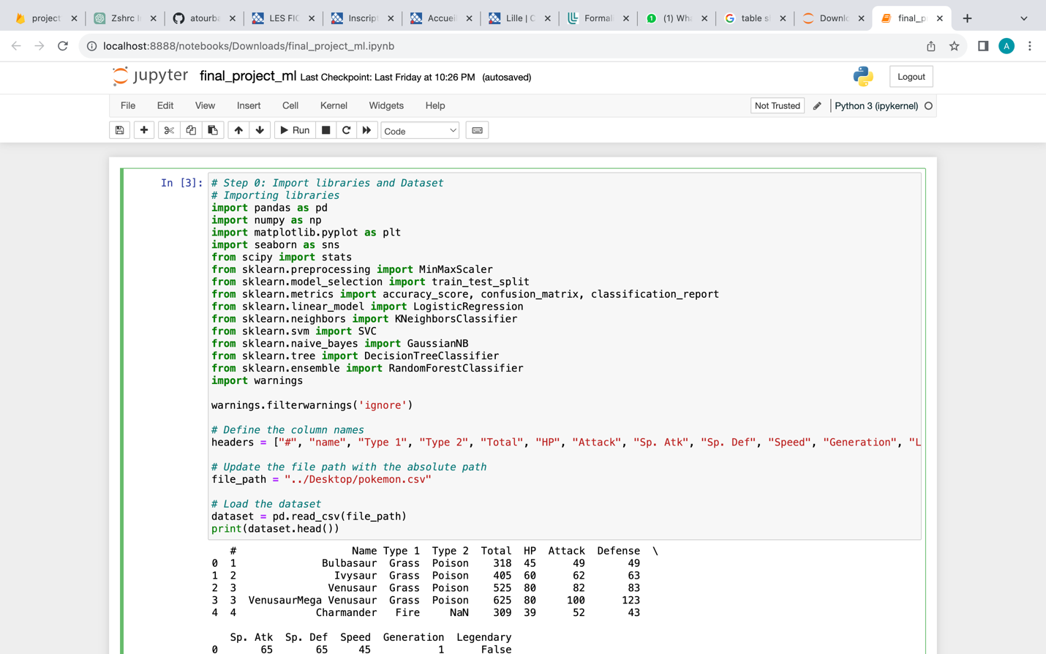

Results:

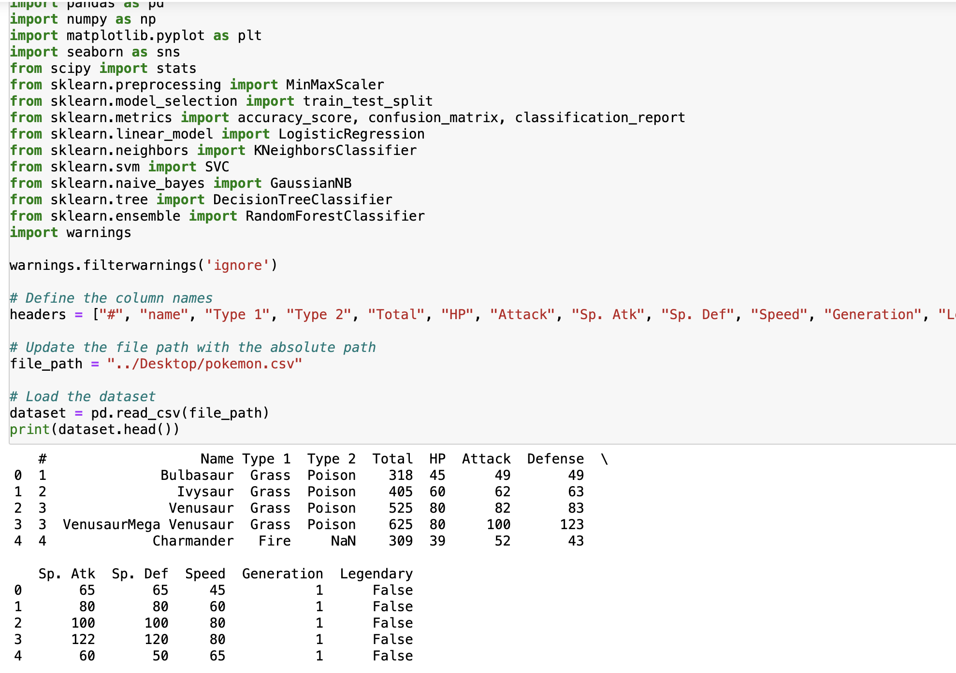

In the following code num_instance calculates the number of rows in the dataset, representing the number of instances or examples and num_attributes calculates the number of columns in the dataset, representing the number of attributes or features. As for attribute_info, it stores the data type information for each attribute in the dataset using the dtypes attribute of the DataFrame and we print the results.

Code:

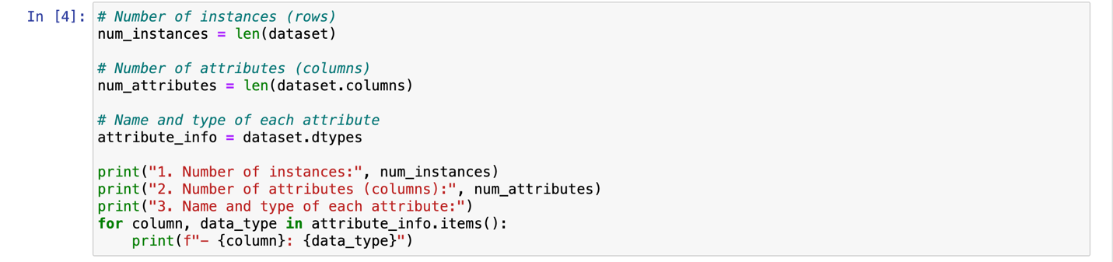

Results:

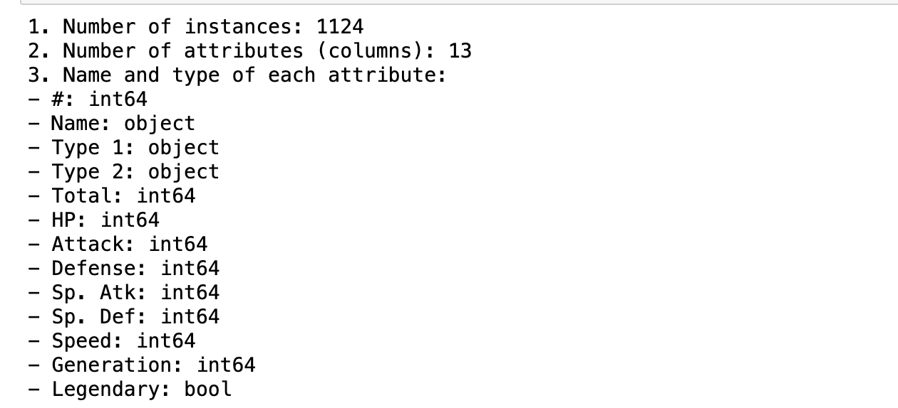

1. Descriptive statistics:

We first previewed the first rows in our data.

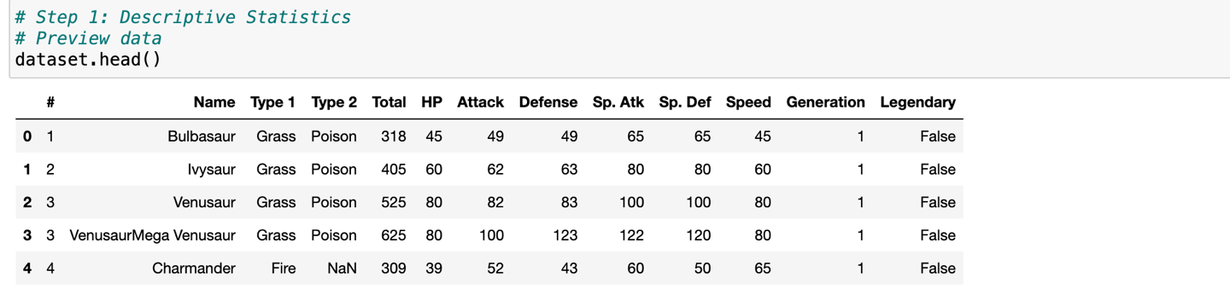

For this code, we are converting empty string in our data to NaN by using dataset.replace which is a standard way of representing missing or undefined data in pandas. As for the use of inplace=True, it modifies the dataset in place, meaning it changes the original dataset without the need to create a new one. Then we count the missing values we have and then for loop iterates over the items in missing_values (column names and corresponding counts of missing values) and prints the results.

Code:

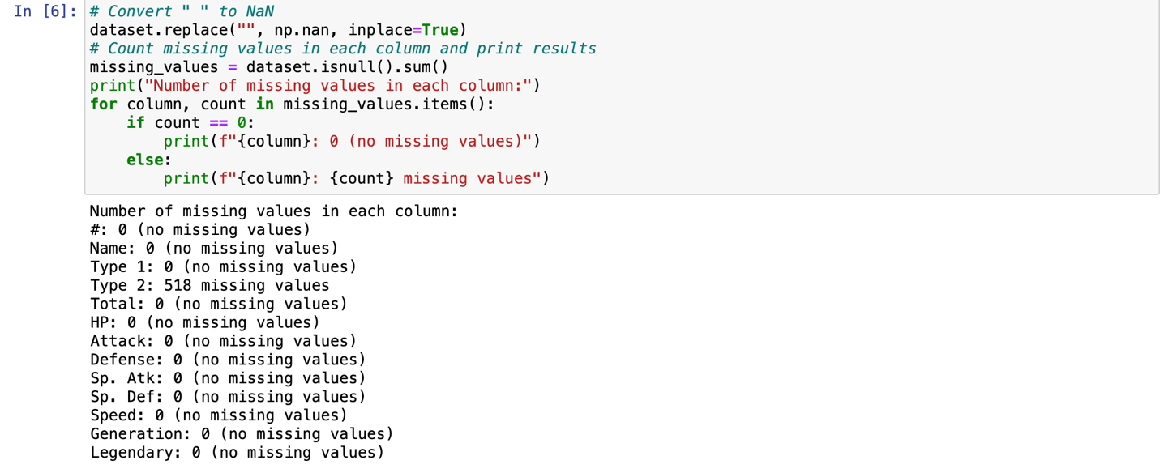

Results:



We then followed by printing dataset dimensions showing number of rows and number of columns.

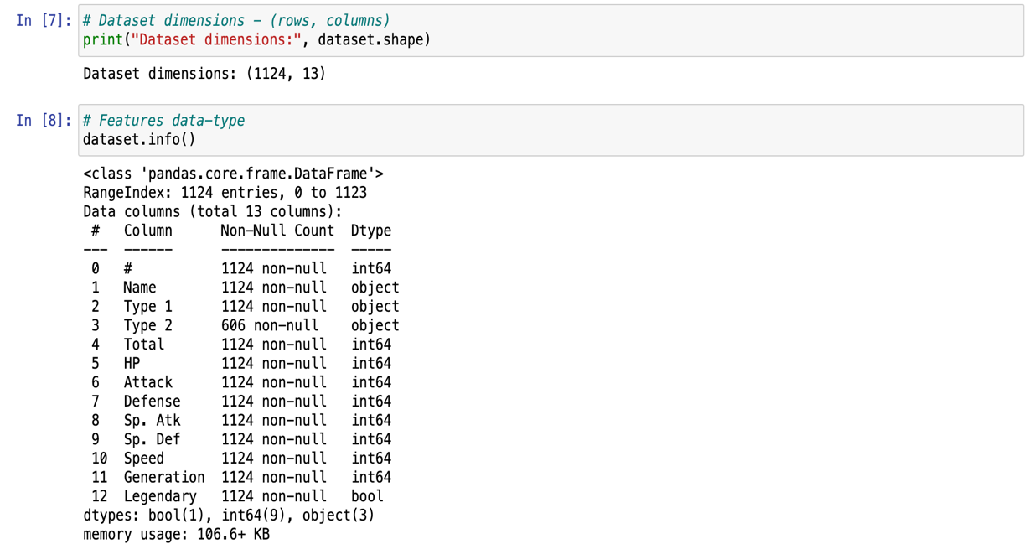

We then showed the detailed info on how many non null values we have and the datatypes.

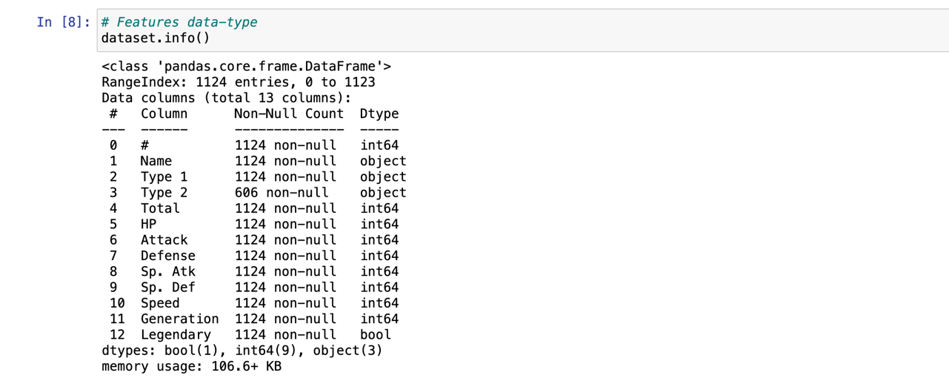

We then showed statistical summary

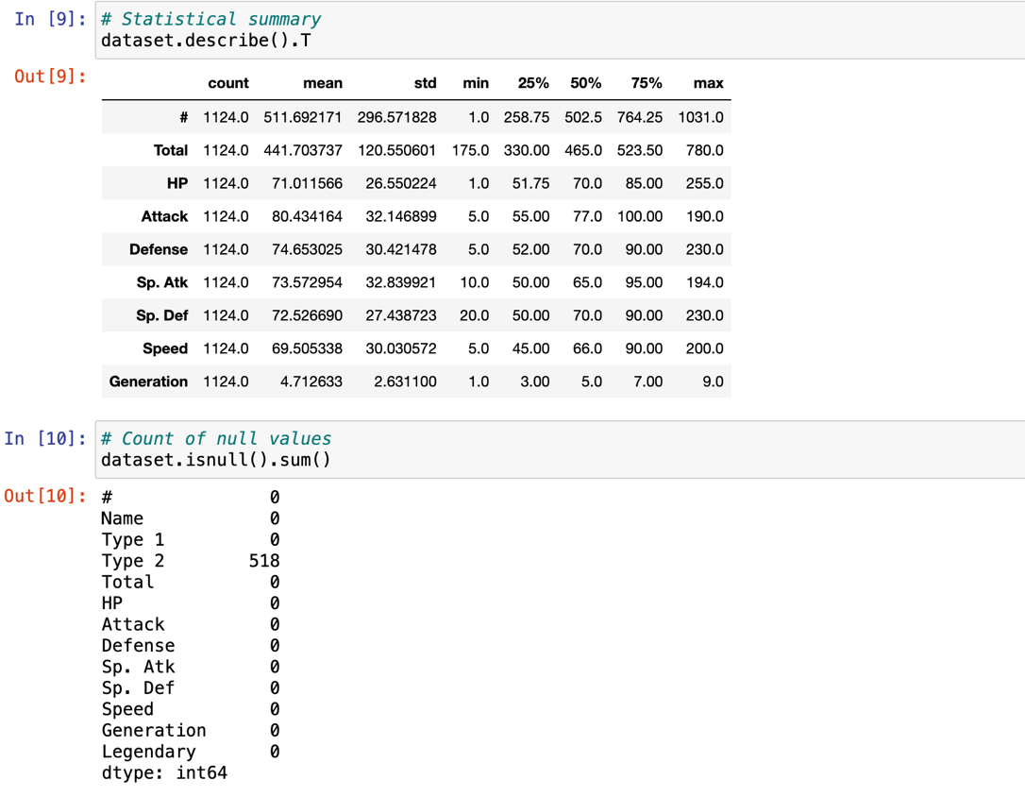

And finally analyzed the data through observations

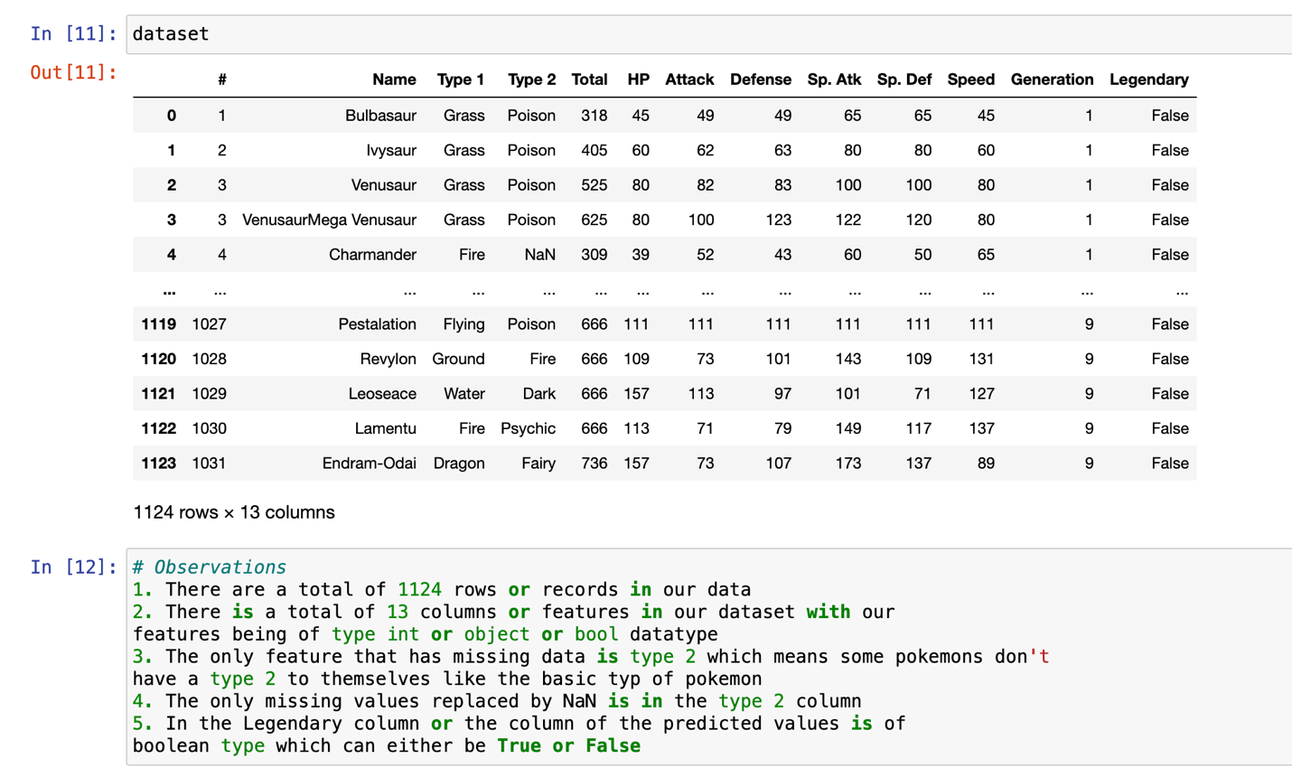

1. Data Visualization

In this part we focused on the distribution of the main attribute we want ot predict which is whether our pokemon is legendary type or not so from seaborn class we used countplot to show distribution, however the training data is slightly more than 80% and tesing less than 20%.

Code:

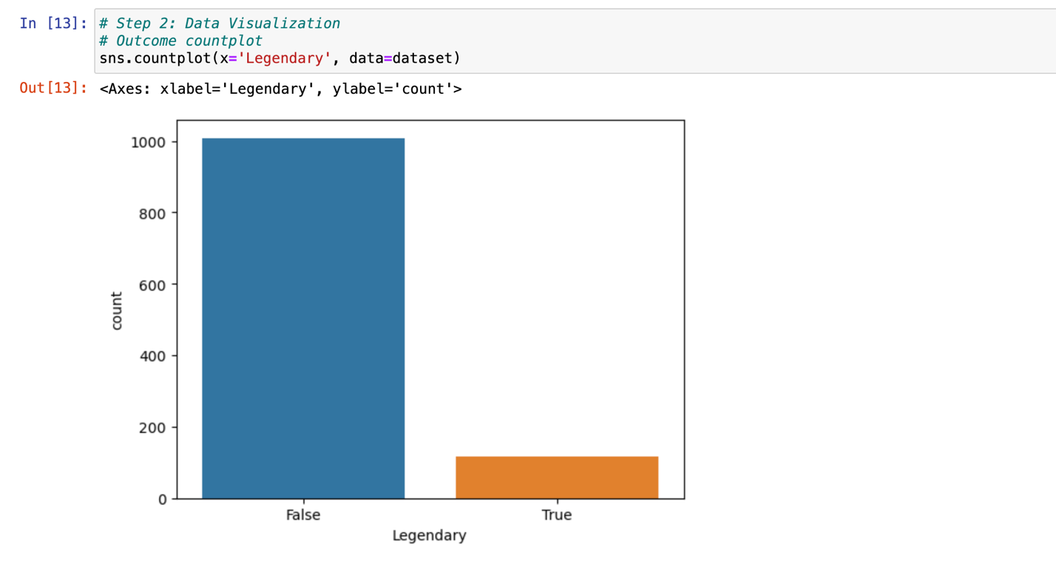

Result:

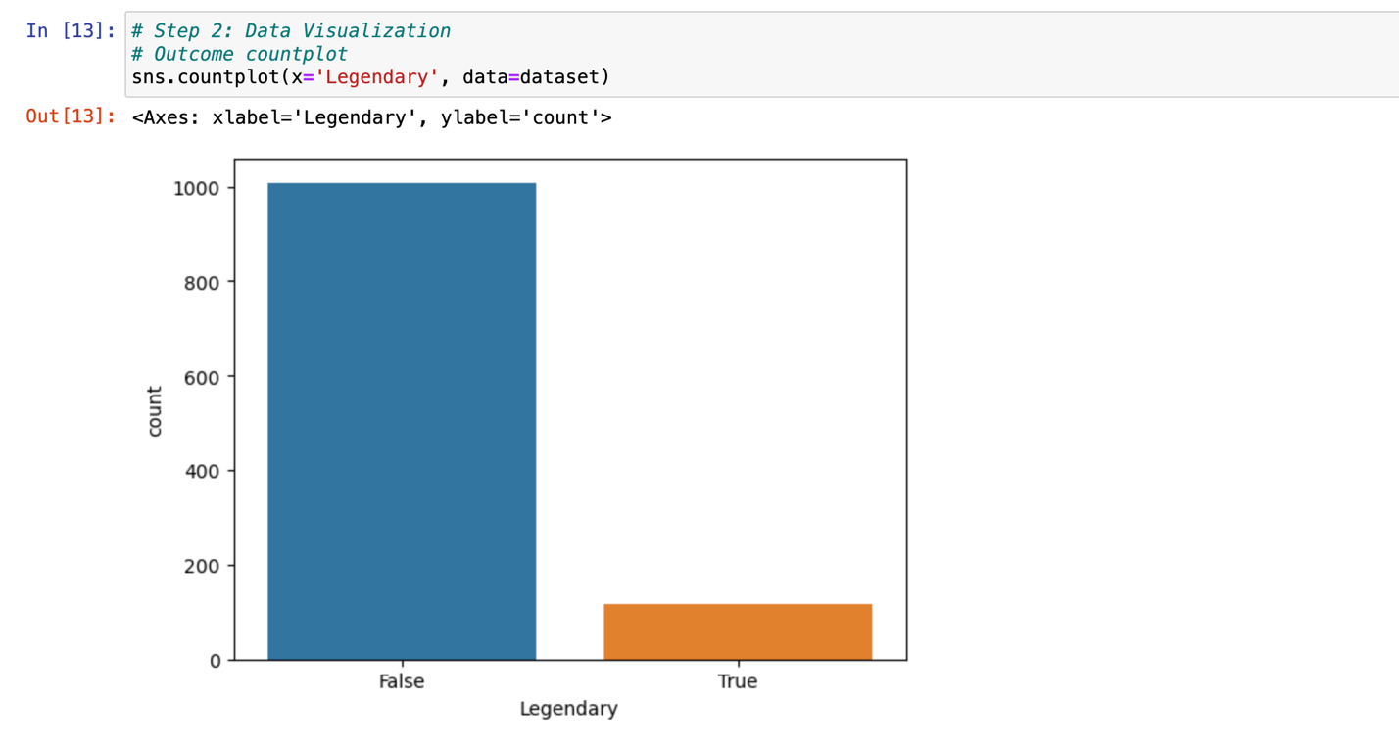

This code generates histograms for numeric columns in the dataset. We started by importing itertools then we selected the numeric columns in the dataset excluding the first two columns and the last column that it the feature to predict. We also set up the figure size for the overall plot. The for loop iterates over each column and creates histogram for each one. We create subplot and display them in a grid layout of 3 columns then we put padding between each histogram and another using width space and height space with 20 bins adding to it the title and showing the plots.

Code:

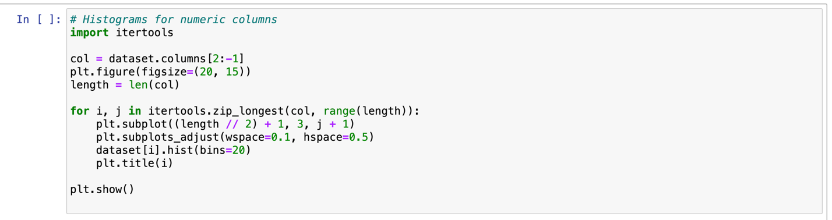

Results:

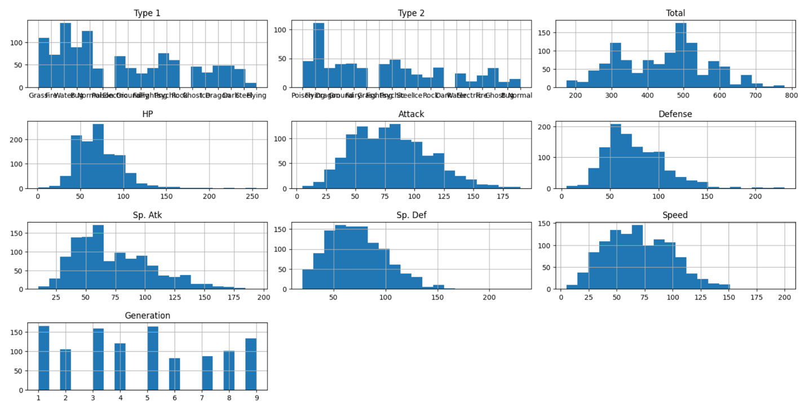

In the next part we generated a scatterplot for the numeric column in our dataset we did that by importing the scatter matrix from pandas plotting library and finally create a scatterplot matrix for each numeric column. The diagonal cells typically show histograms of individual variables. The resulting plot provides a visual representation of the relationships between pairs of numeric variables, helping to identify patterns and correlations in the data.

Code:



Results:

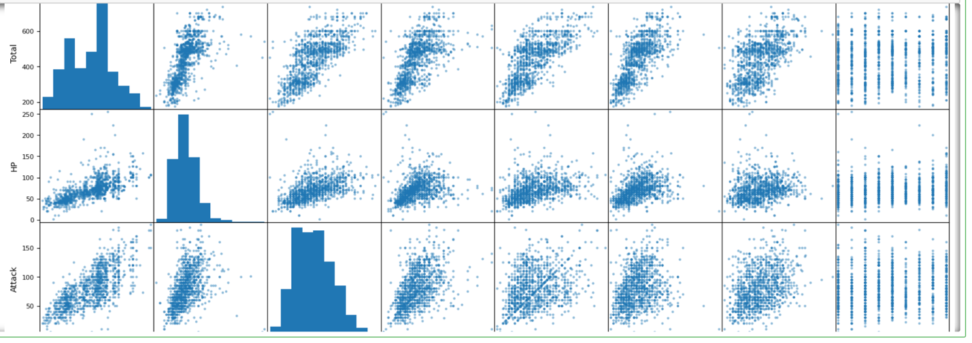

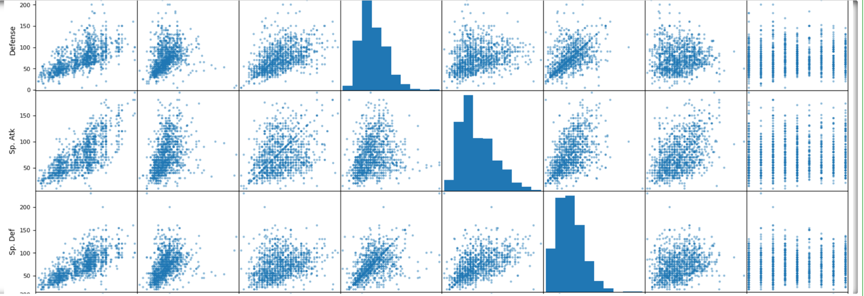

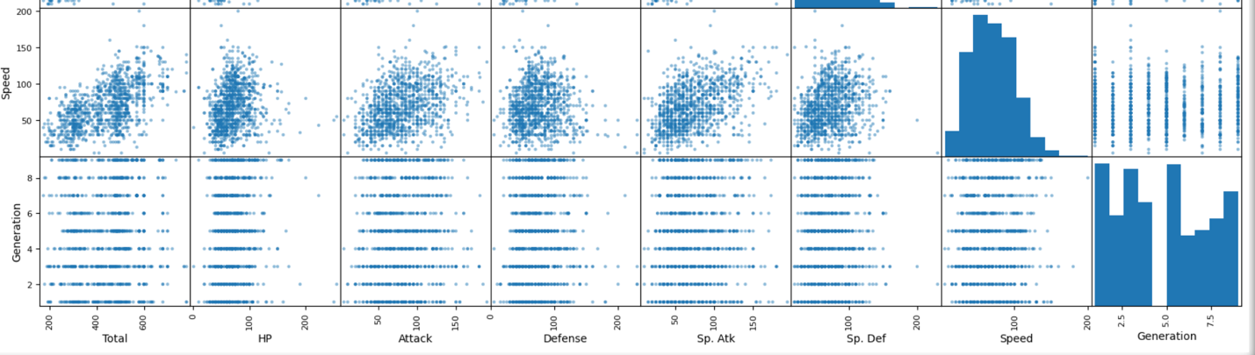

Then we decided to generate pairplot for the columns using seaborn we first selected all columns starting with the third one exluding our object datatypes (Type 1 and Type 2). The next line creates a grid of scatter plots for pairs of variables The data parameter specifies the dataset, and hue=Legendary adds color differentiation based on the Legendary column. Each point in the scatterplots represents an observation, and different colors are used for different values in the Legendary column.

Code:

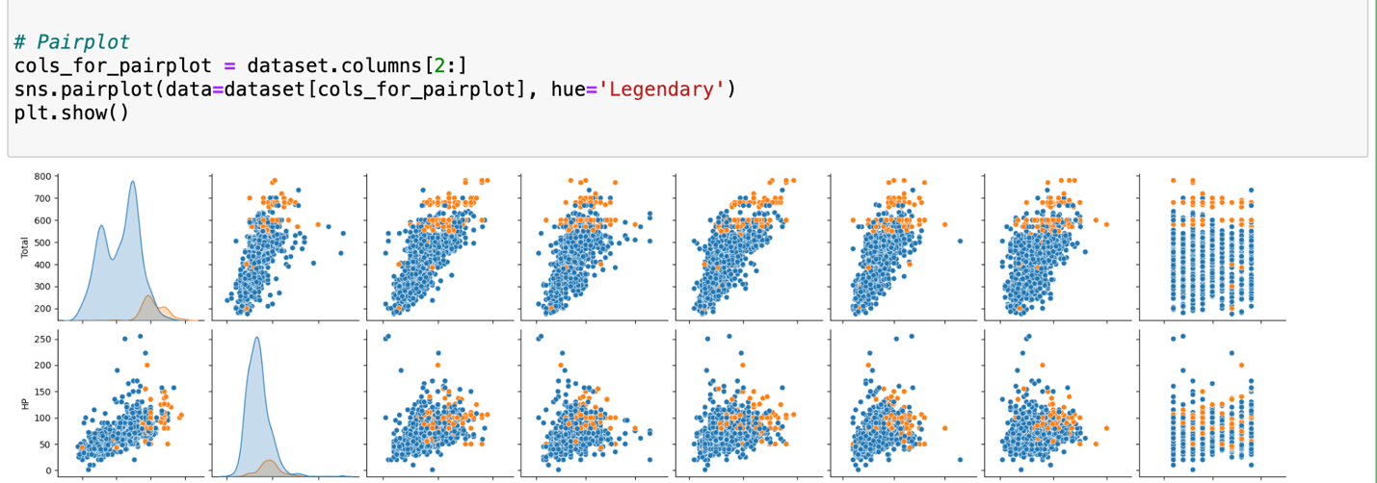

Results:

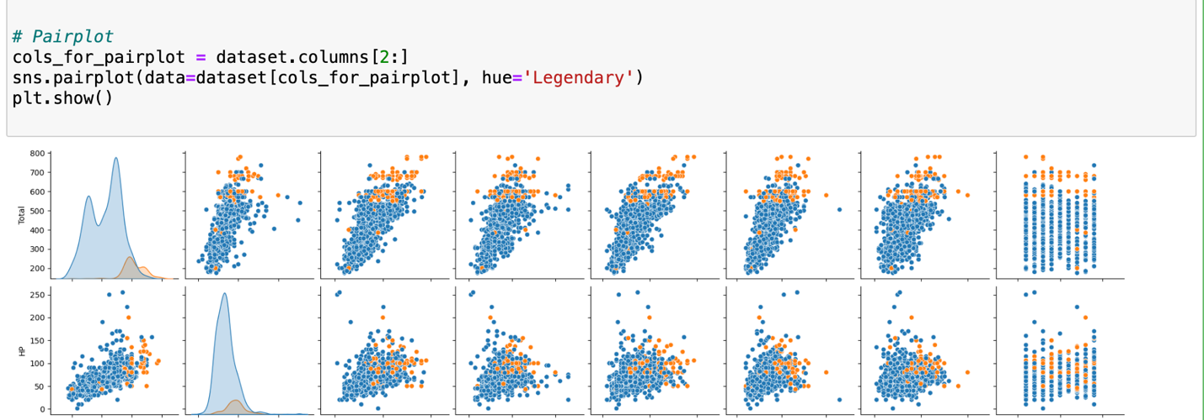

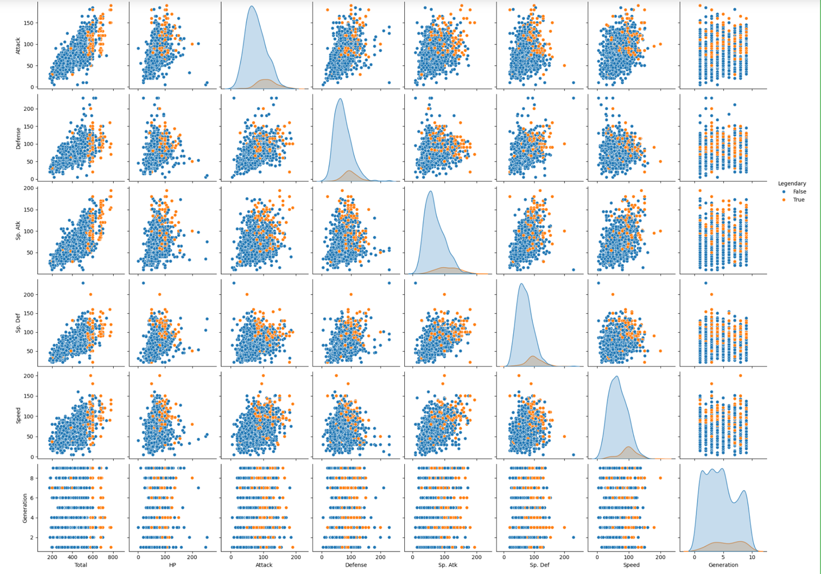

Now for generating our heatmap, we select the numeric columns and then calculates the correlation matrix for the numeric columns. The correlation matrix shows how each numeric variable correlates with every other numeric variable in the dataset. The result is a square matrix where each element represents the correlation between the i-th and j-th variables. Clearly the only high correlation we got aside from the main diagonal is between the # column and the generation column meaning they could be combined into 1 feature (0.99)

Code:

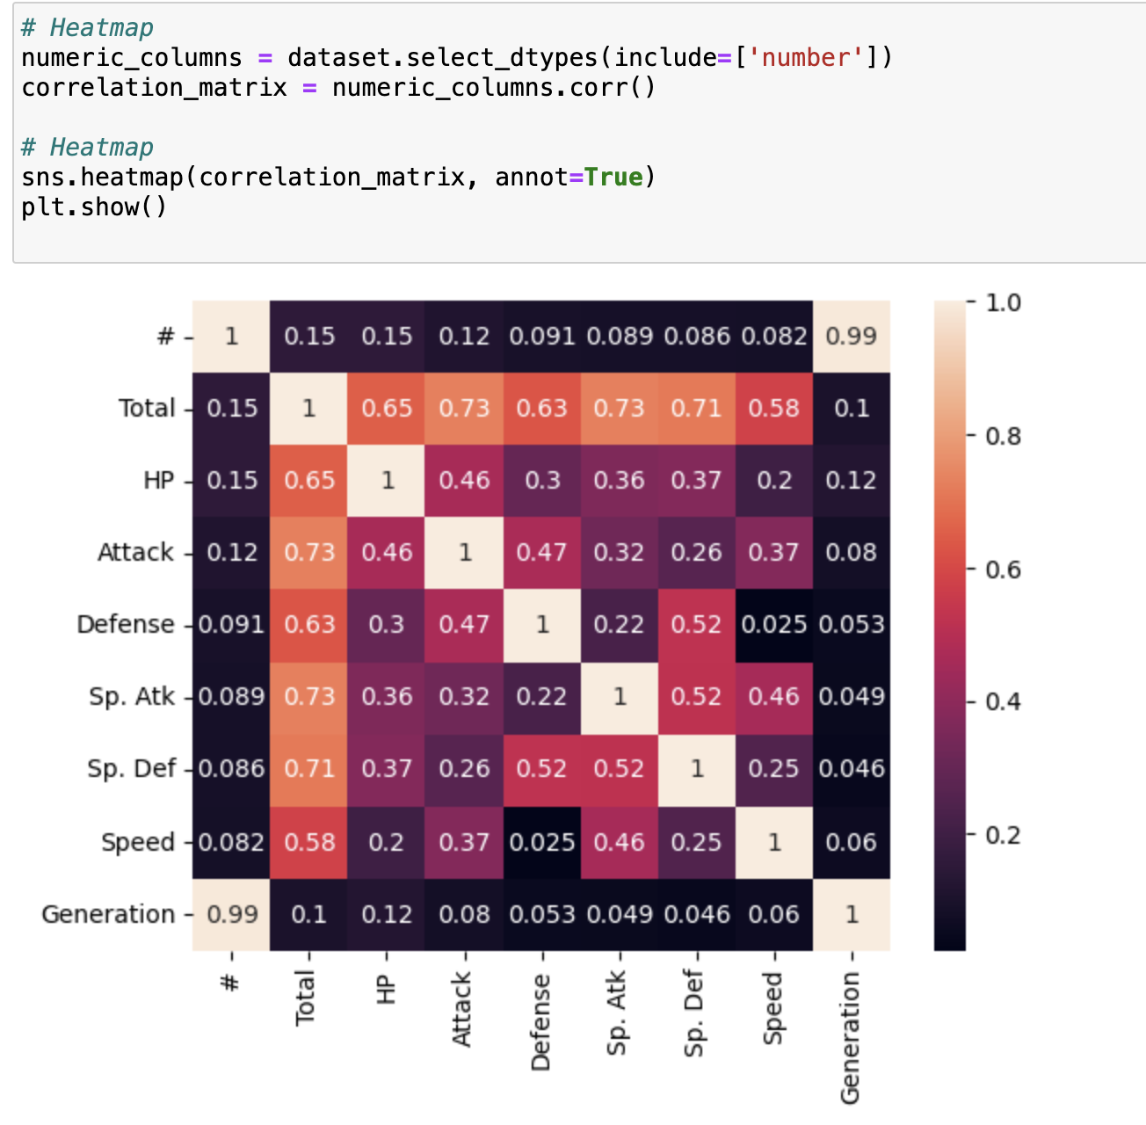

Results:



1. Data Preprocessing

In this step, we replaced zero values with NaN in each column then replaced NaN values with mean values for every numeric column using the na and mean functions.

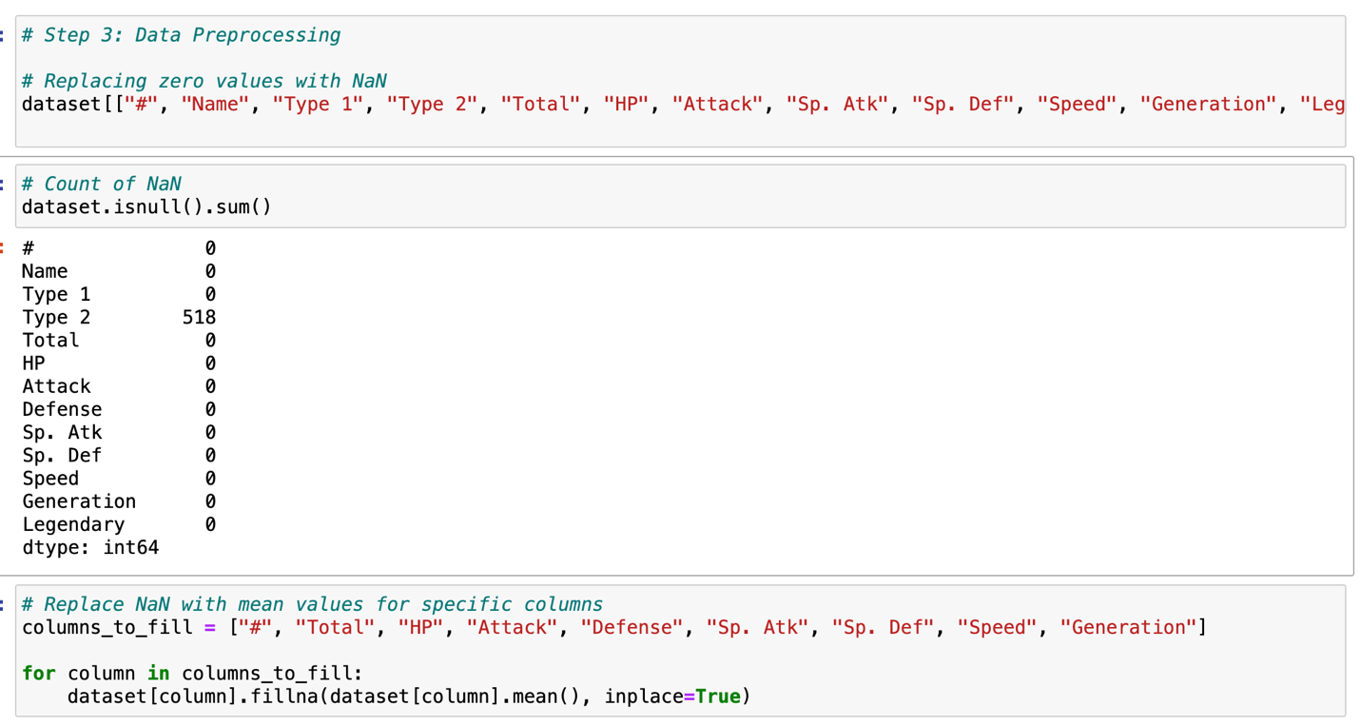

We printed the statistical summary showing each method (min, max, Q1, Q2, Q3, count, std and mean). Then we performed feature scaling on selected numeric columns in the dataset using Min-Max scaling and then combined the scaled numeric data with the non-numeric columns.

Code:

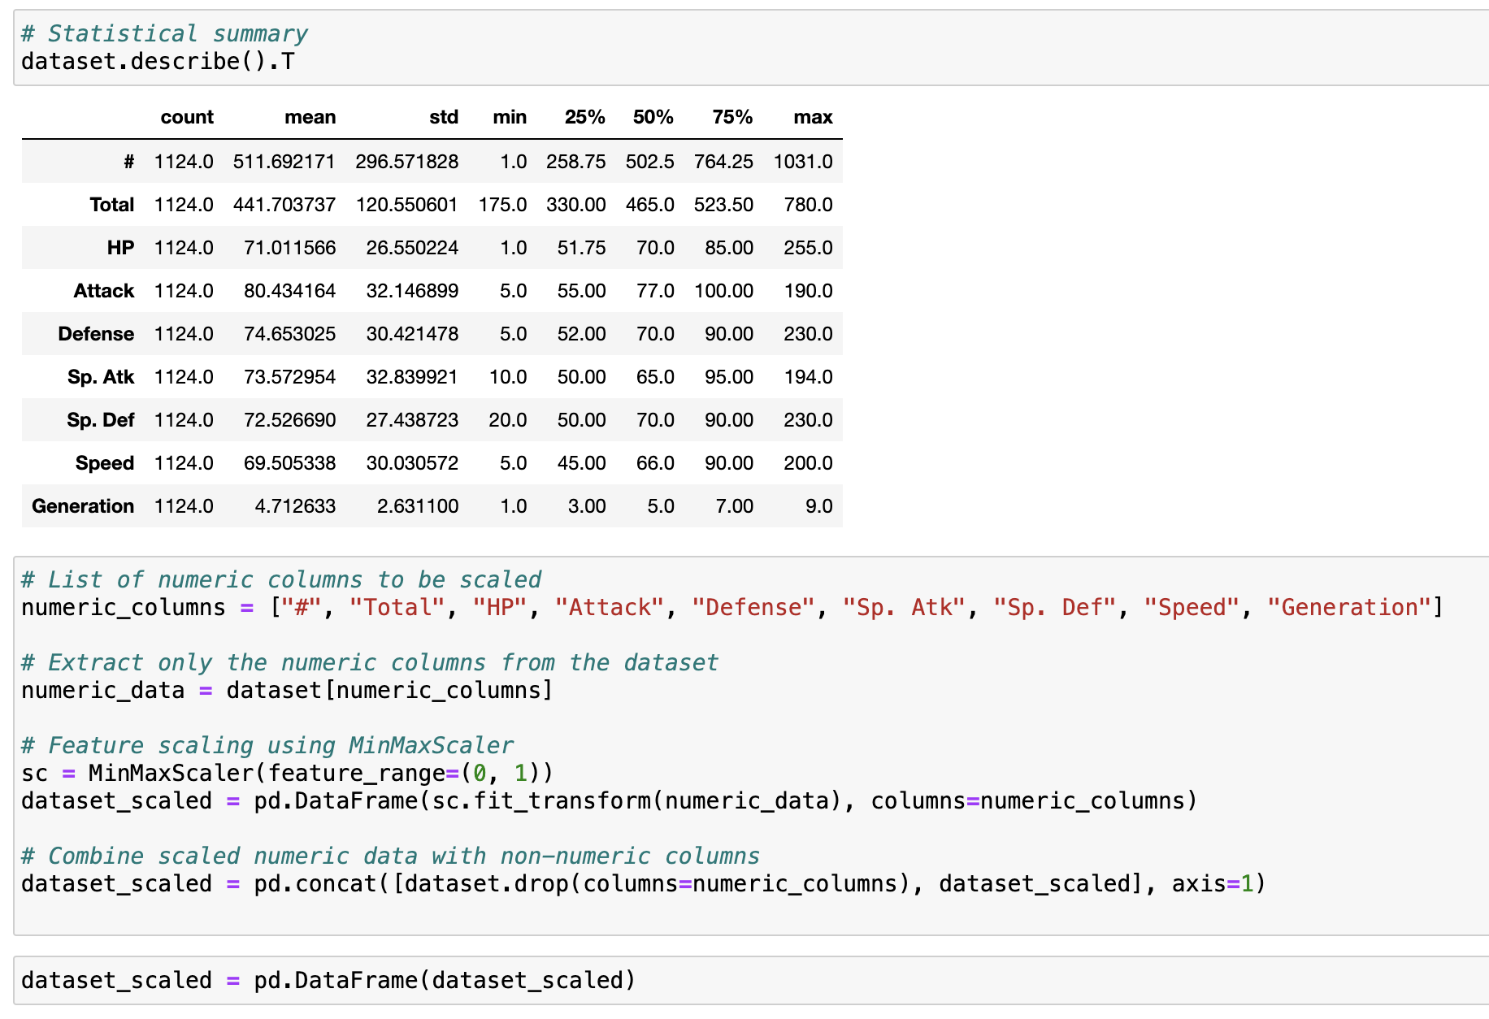

In the next step, out of the numeric columns we selected specific features instead of taking them all and from there we took those selected features’ values and stored them in the X array as for the Y array it contains the only feature, we want to predict being Legendary. Then we splitted the dataset into training and testing sets, as for the train test split function, it takes the input features (X) and the target variable (Y) and splits them into training and testing sets. And finally we check the dimensions training and testing for X and Y and printed them.

Code:

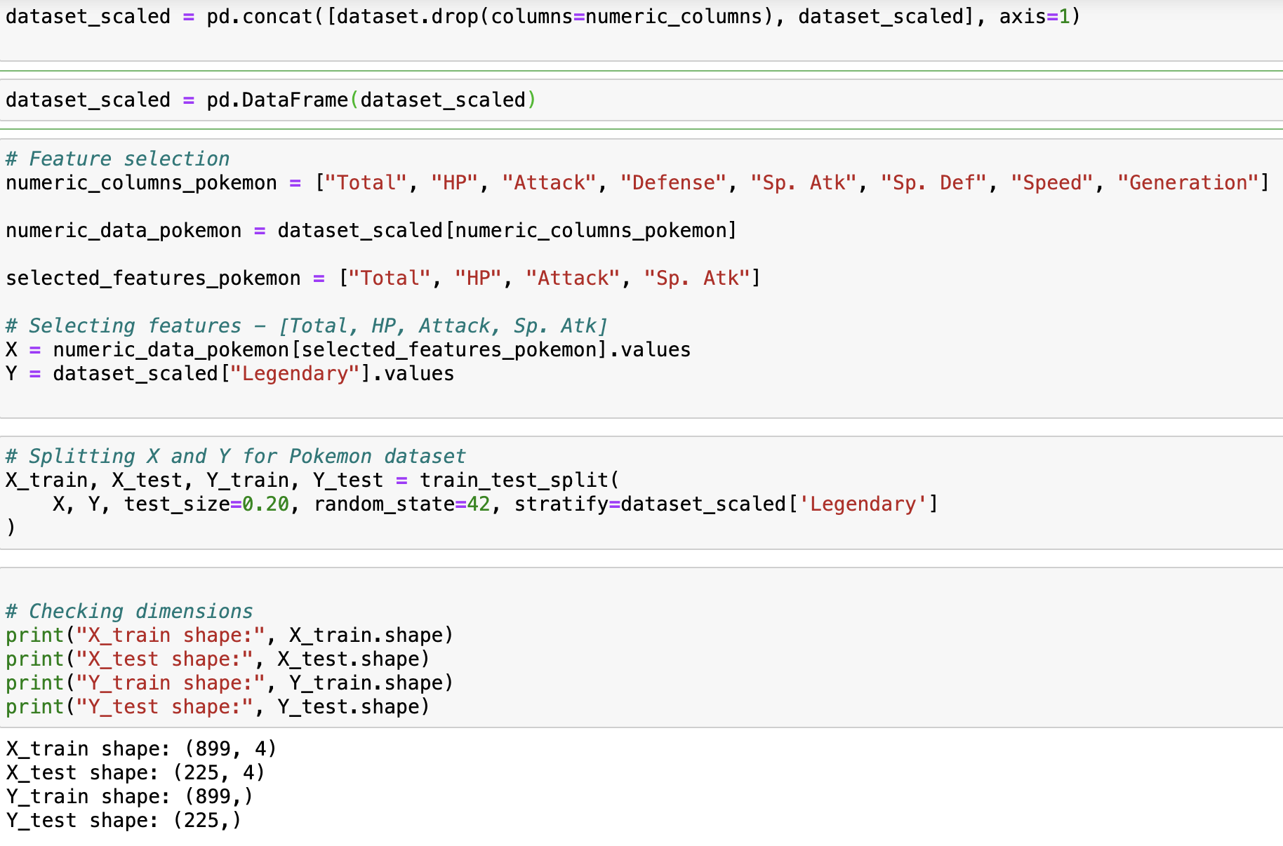

1. Data Modeling

We then implemented Logistic Regression algorithm in Python using the scikit-learn library. As for the random state 42 sets random seed for reproducibility. When the same seed is used, the results of the algorithm will be the same across different runs. As for the logreg function the fit method is used to train logistic regression model using X train and Y train as arguments. the goal is to model the probability that a given instance belongs to a particular class. The model learns a set of coefficients for each feature, and these coefficients are used to calculate the log-odds (logit) of the probability. The logistic function is then applied to convert the log-odds into probabilities.

Code & Result:

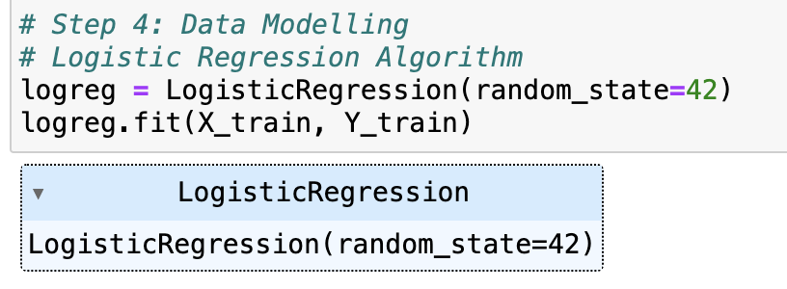

For the next algorithm we implemented, KNN used for a range of values of k (number of neighbors) and selecting the best k based on the highest accuracy on a validation set. We first initialized a list of values from 1 to 30, representing the number of neighbors (k) to be considered. The array acc stores the accuracy scores for different values of k. then loop through values of k creating KNN model with I neighbors then training our model before making testing and making predictions then we calculated and stored the accuracy for each k using as arguments Y test the prediction of the X test. After exiting the for loop, we tried finding the best k neighbor with highest accuracy printed results and create and train the final KNN model with the best value of k using KNeighborClassifier function.

Code:

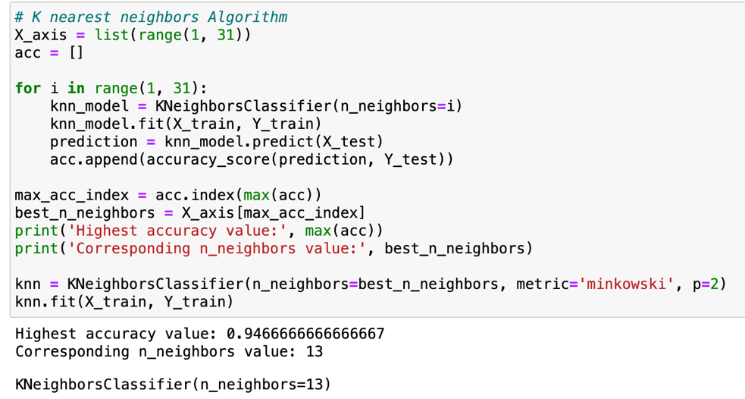

Result:

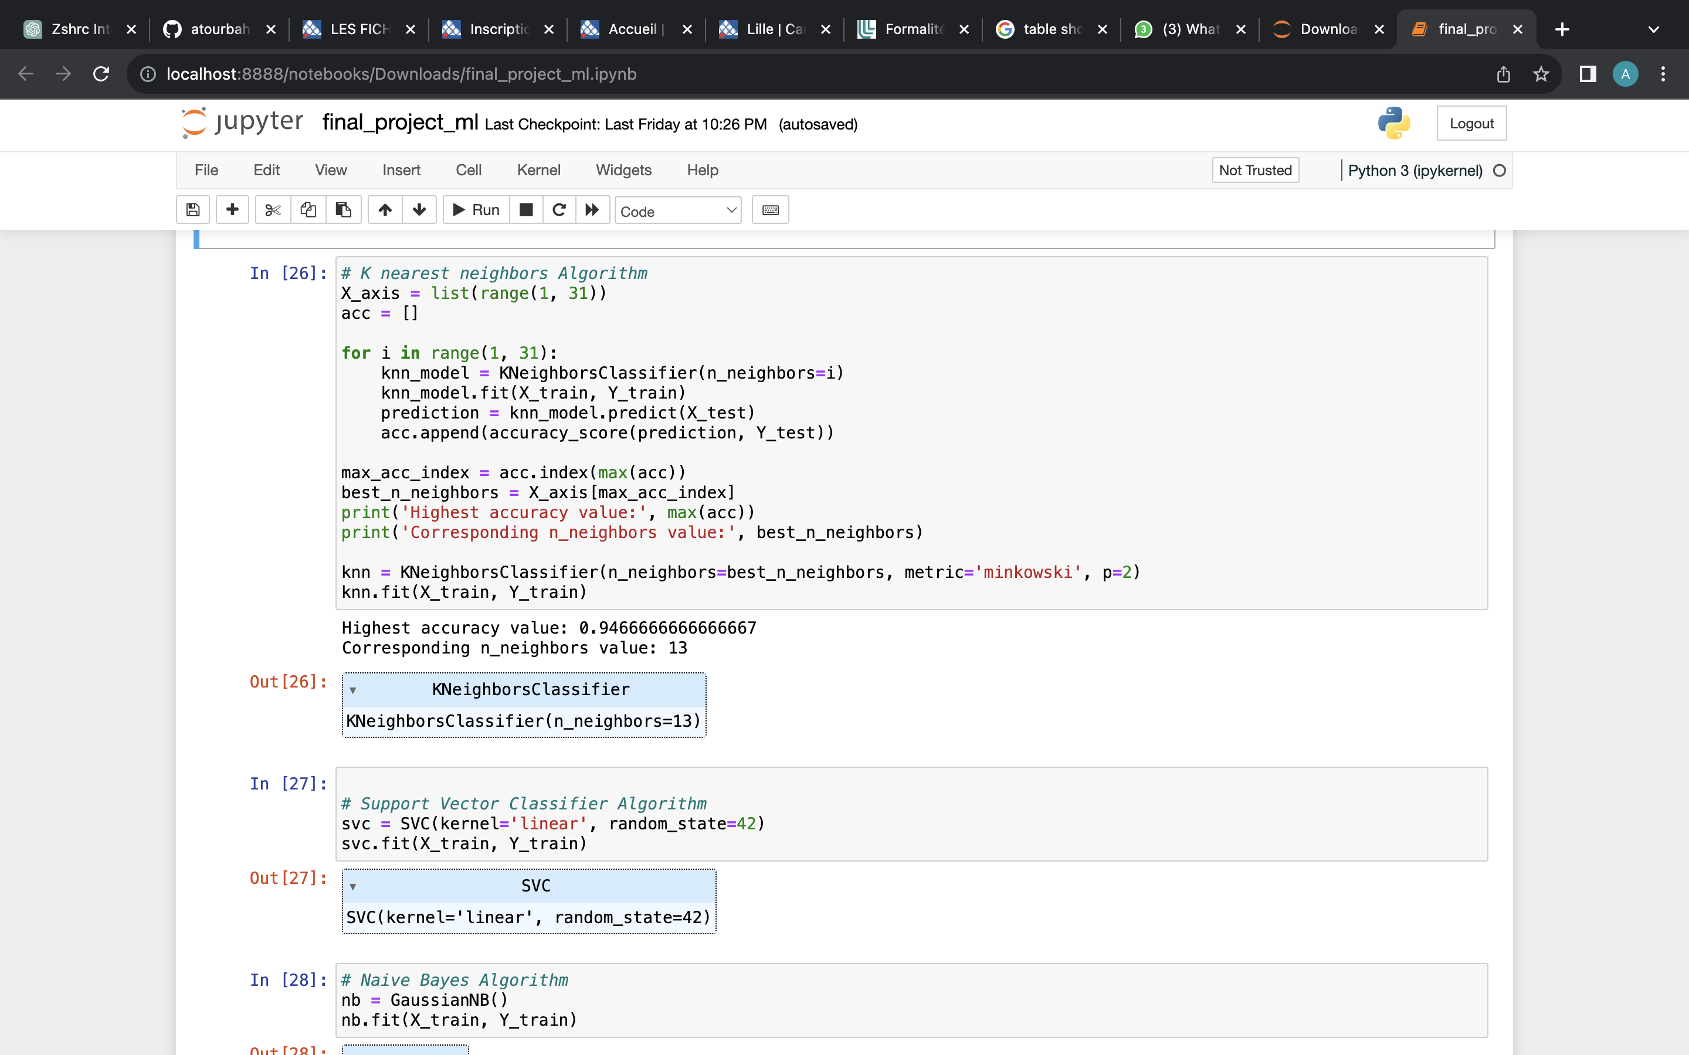

The subsequent algorithm applied is the Support Vector Classifier (SVC), instantiated with a linear kernel. The parameter kernel='linear' specifies the utilization of a linear kernel, and random_state=42 establishes a seed for random number generation to ensure reproducibility. Regarding the fit method, it is employed to train the SVC model on the training data. The X_train parameter signifies the feature matrix of the training set, while Y_train denotes the corresponding labels (target values) for the training set. The Support Vector Classifier is a machine learning algorithm designed for classification tasks. With a linear kernel, the algorithm endeavors to identify a hyperplane that optimally separates the classes in the feature space. The fit method refines the model's parameters based on the provided training data.

Code & Result:

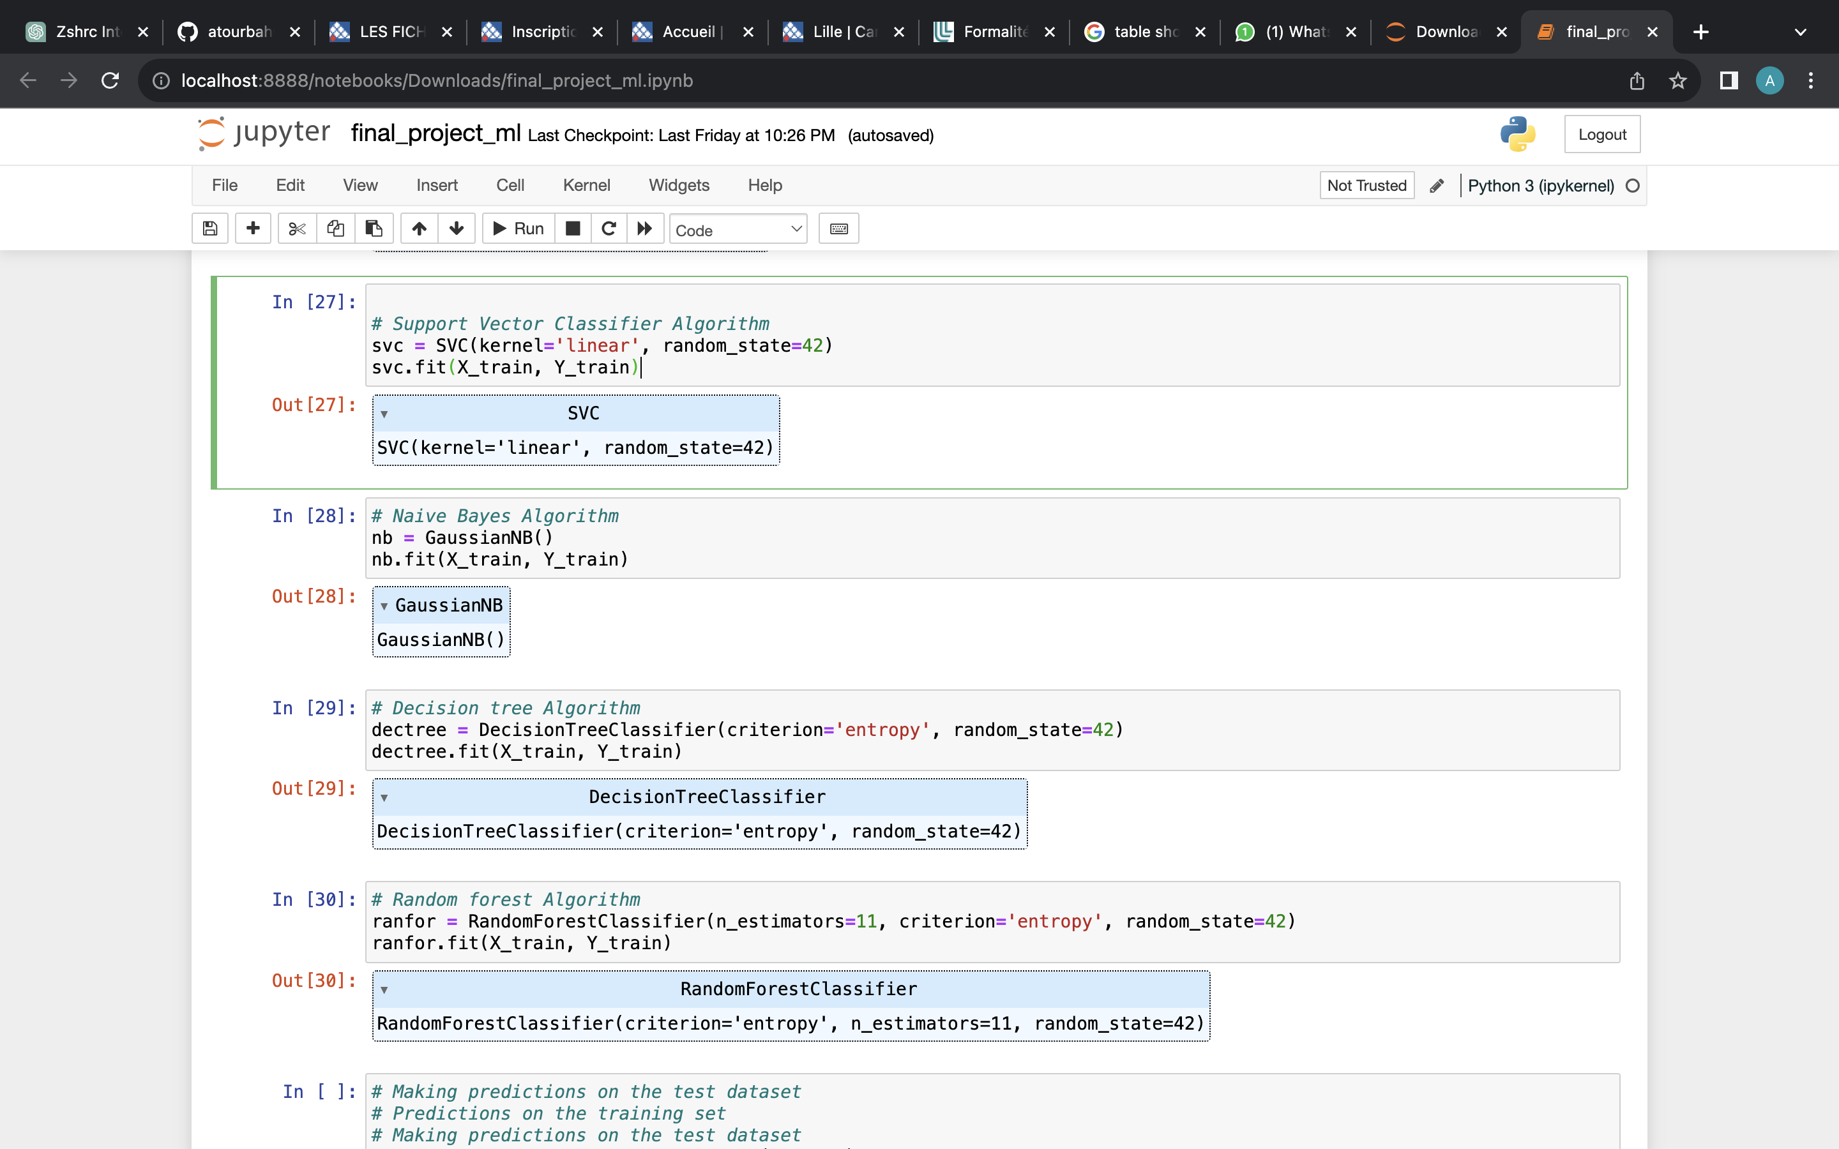

We also used same method on Naïve Bayes algorithm for our training sets.

Code & Result:

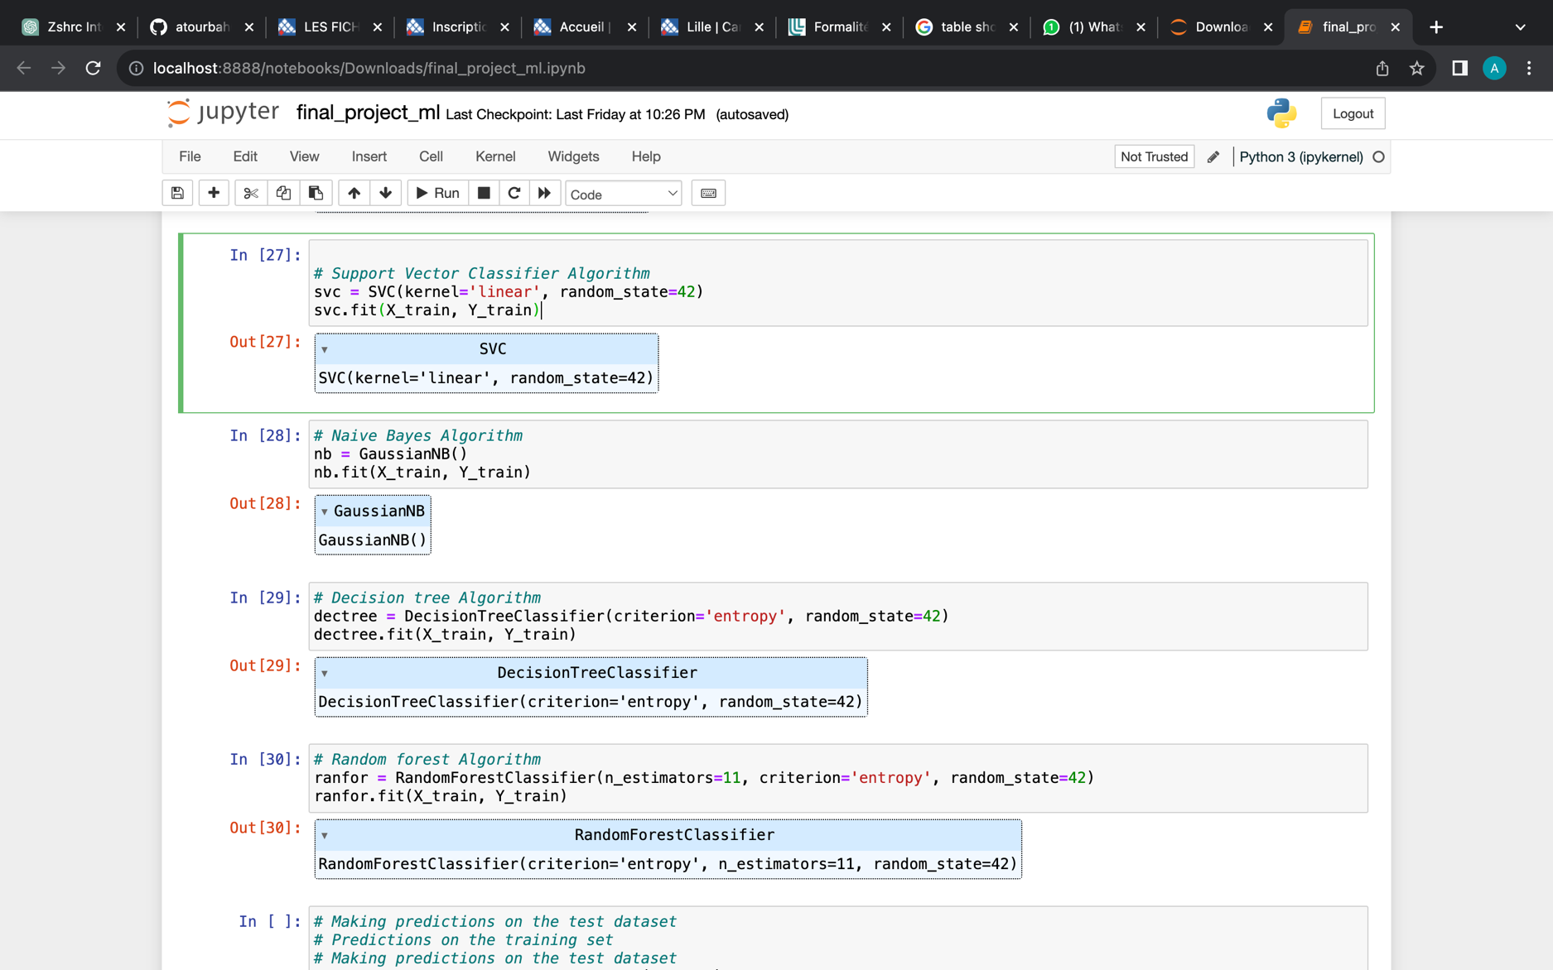

We also tried Decision tree algorithm using the function to measure which is entropy and setting a seed of 42 for random number generated for reproducibility.

Code & Result:



And for the last algorithm used, Random Forest uses the method Random Forest Classifier instance with 11 decision trees, uses entropy as the criterion for splitting, and sets the random seed to 42 for reproducibility in random processes.

Code & Result:



Finally we made predictions using each model on X variable training and testing set. These predictions are the model's outputs for the respective datasets based on the features provided. The predict method is used for each model to generate these predictions.

Code:

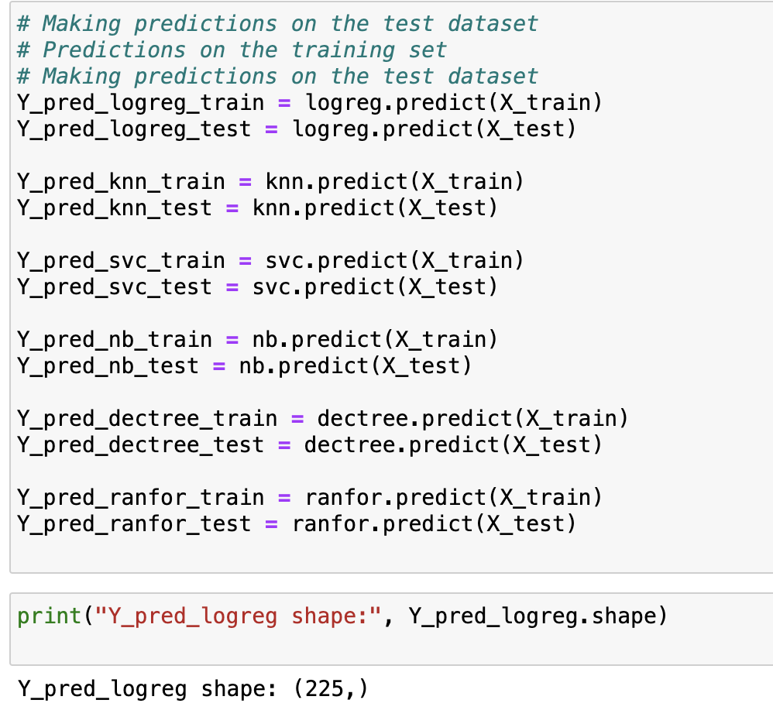

We finally print for example the logistic regression for the testing set of X.

Code & Result:

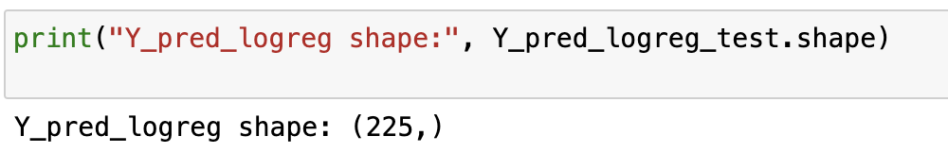

1. Model Evaluation

First for the logistic regression, we used accuracy_score to measure the accuracy of the model's predictions, precision_score to evaluates the precision of the model, particularly important in binary classification, recall_score to measures the recall (sensitivity or true positive rate) of the model and f1_score to computes the F1 score, which is the harmonic mean of precision and recall. The classification_report generates a text report of key classification metrics. We also used binary to keep value between range [0,1]. We concluded that we got very high values for accuracy in training and testing as well as both precisions (training and testing) however the recalls we got are low the f1 score in both is neither low nor high near 50% almost.

Code:

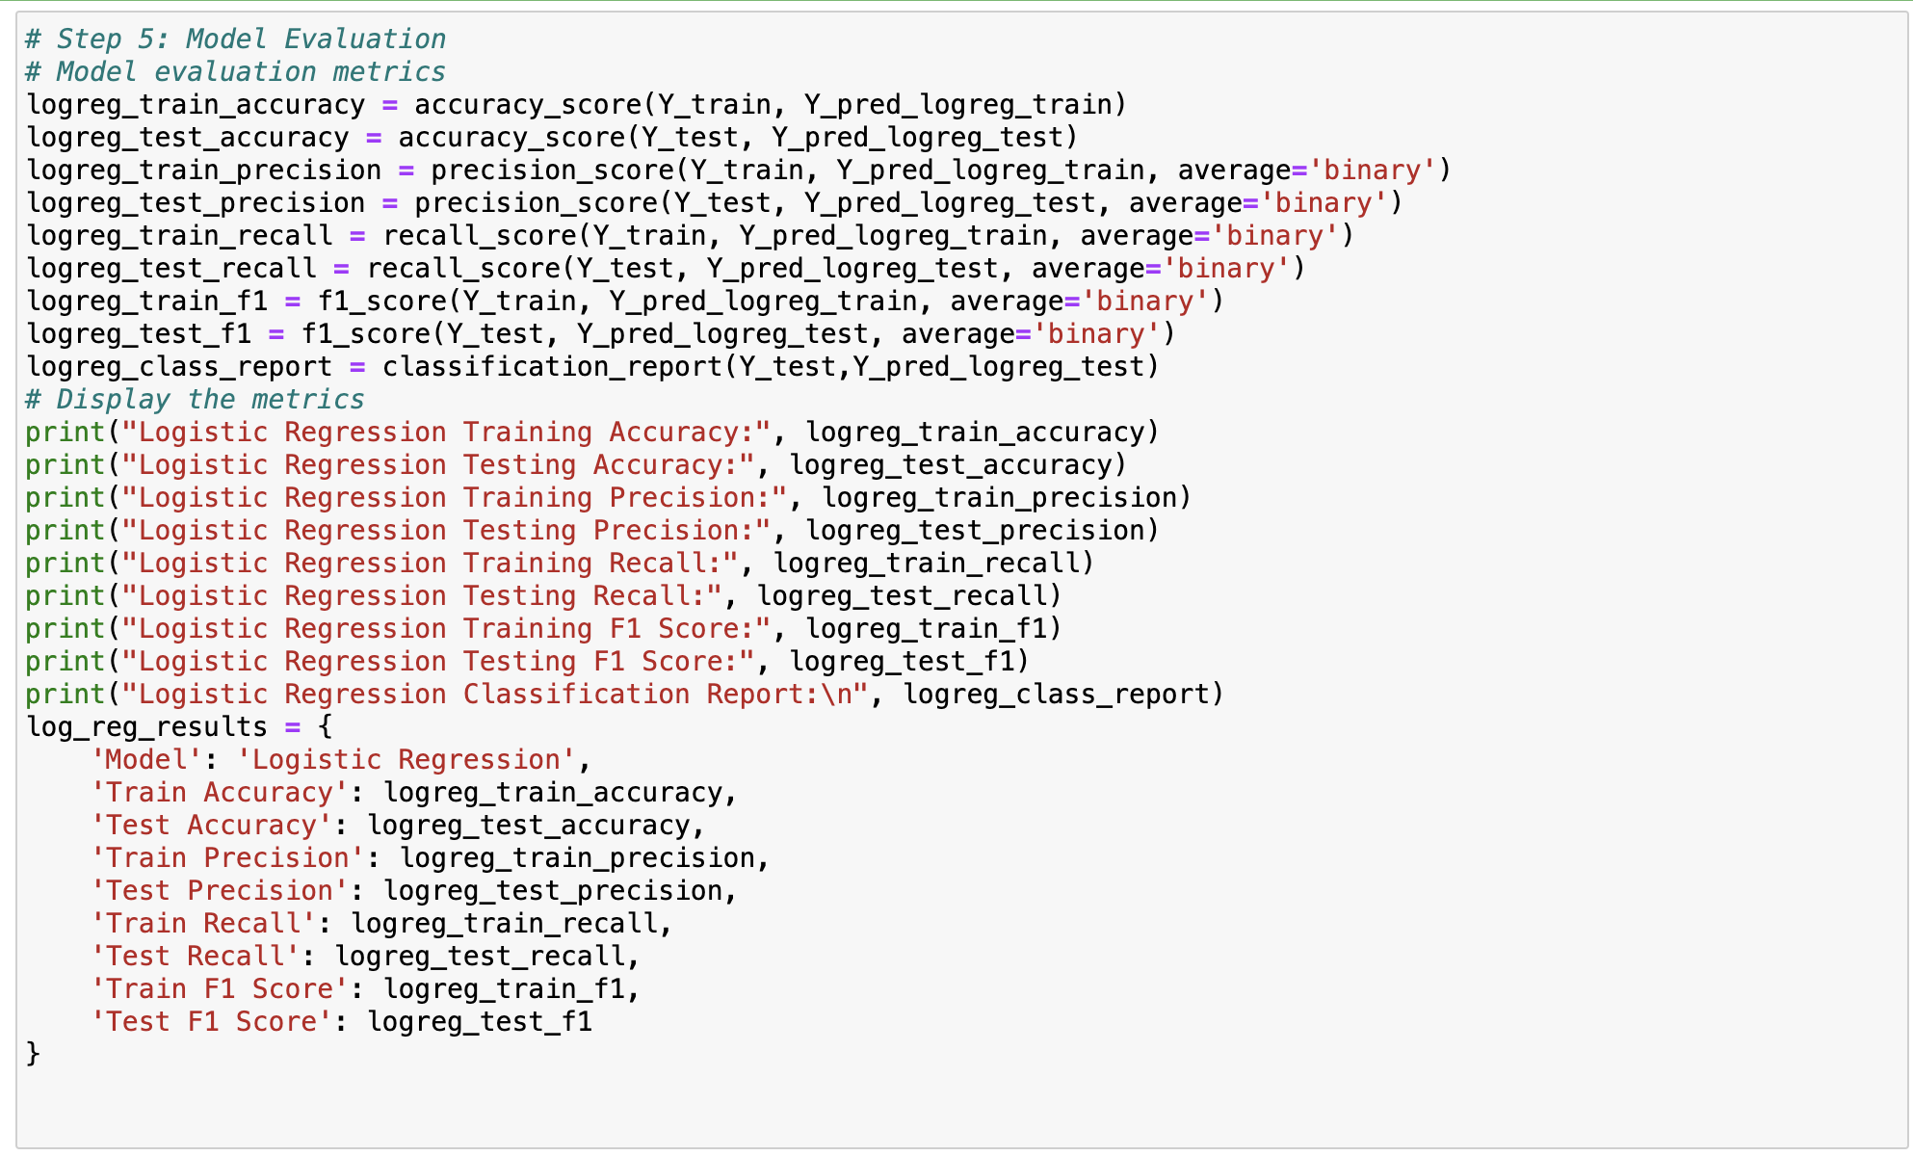

Result:

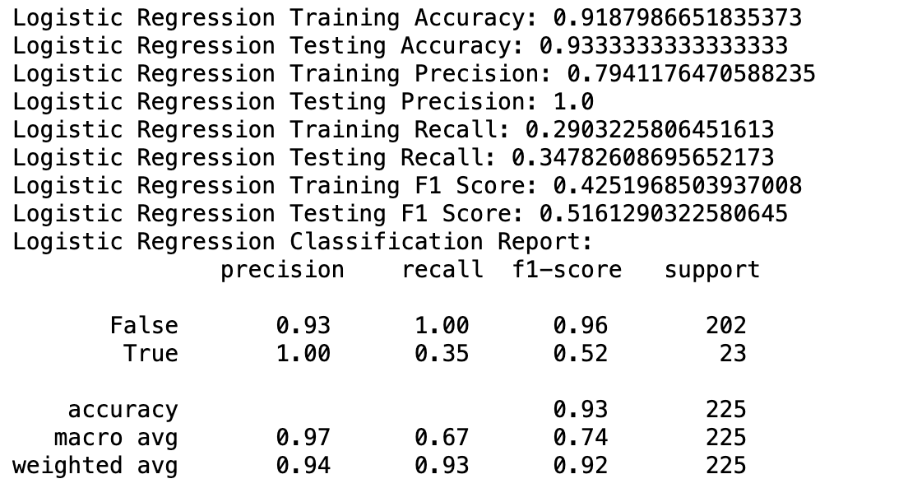

We did the same for KNN using the same variable function as logistic (accuracy, precision…).

Using KNN we obtained very high accuracy, high precision, medium recall and high f1 score in in training and testing on average.

Code:

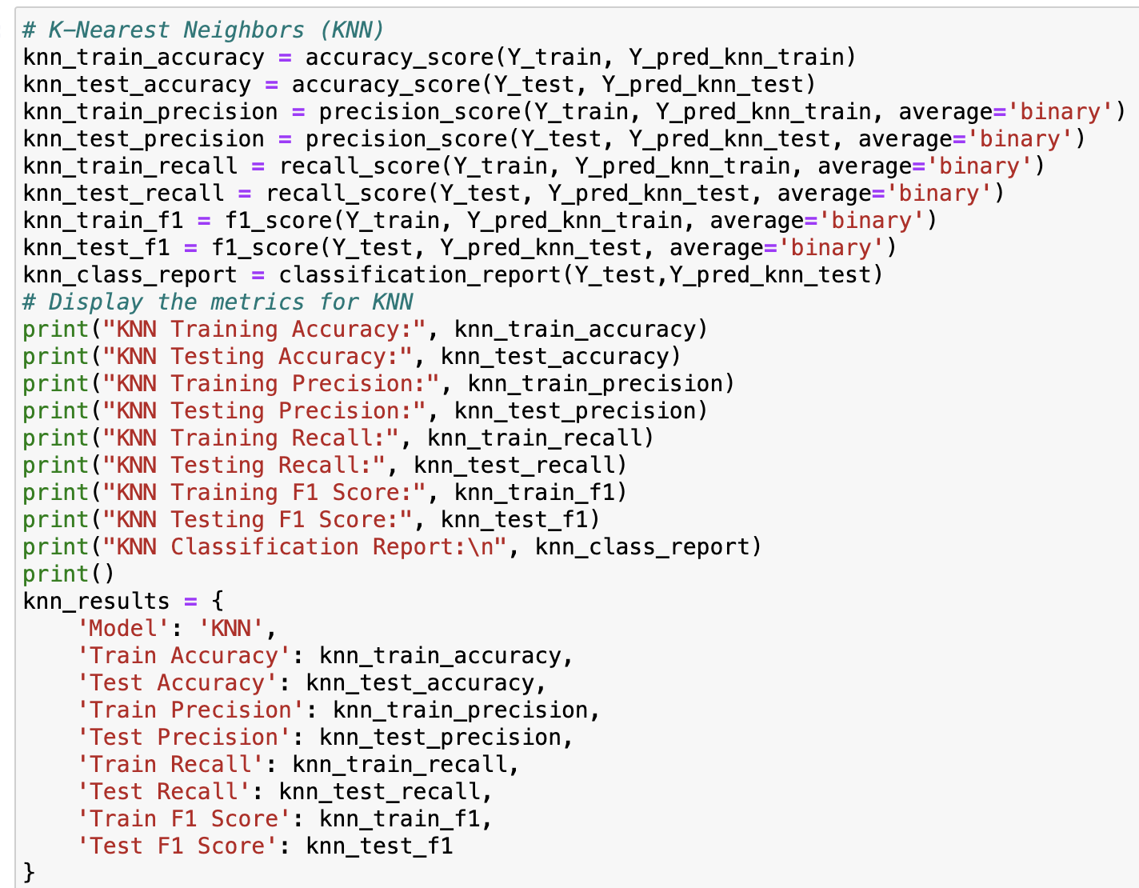

Result:

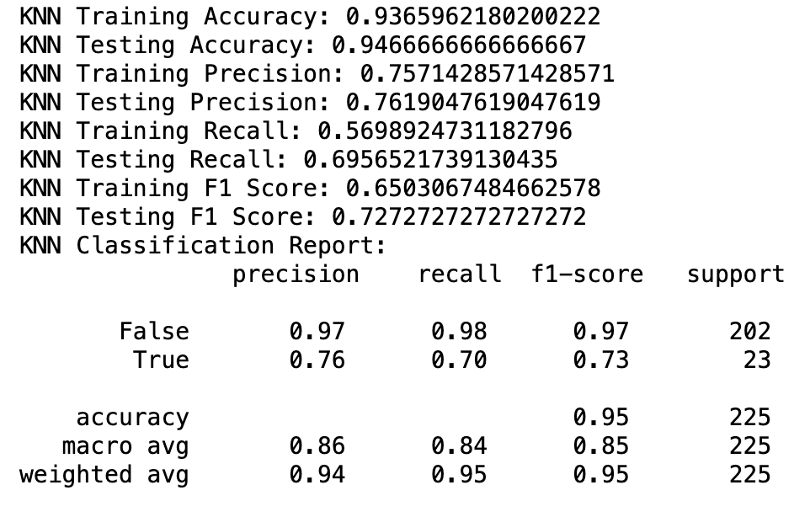

For Naïve Bayes we obtained a very high accuracy but a medium precision a high recall and a medium f1 score.

Code:

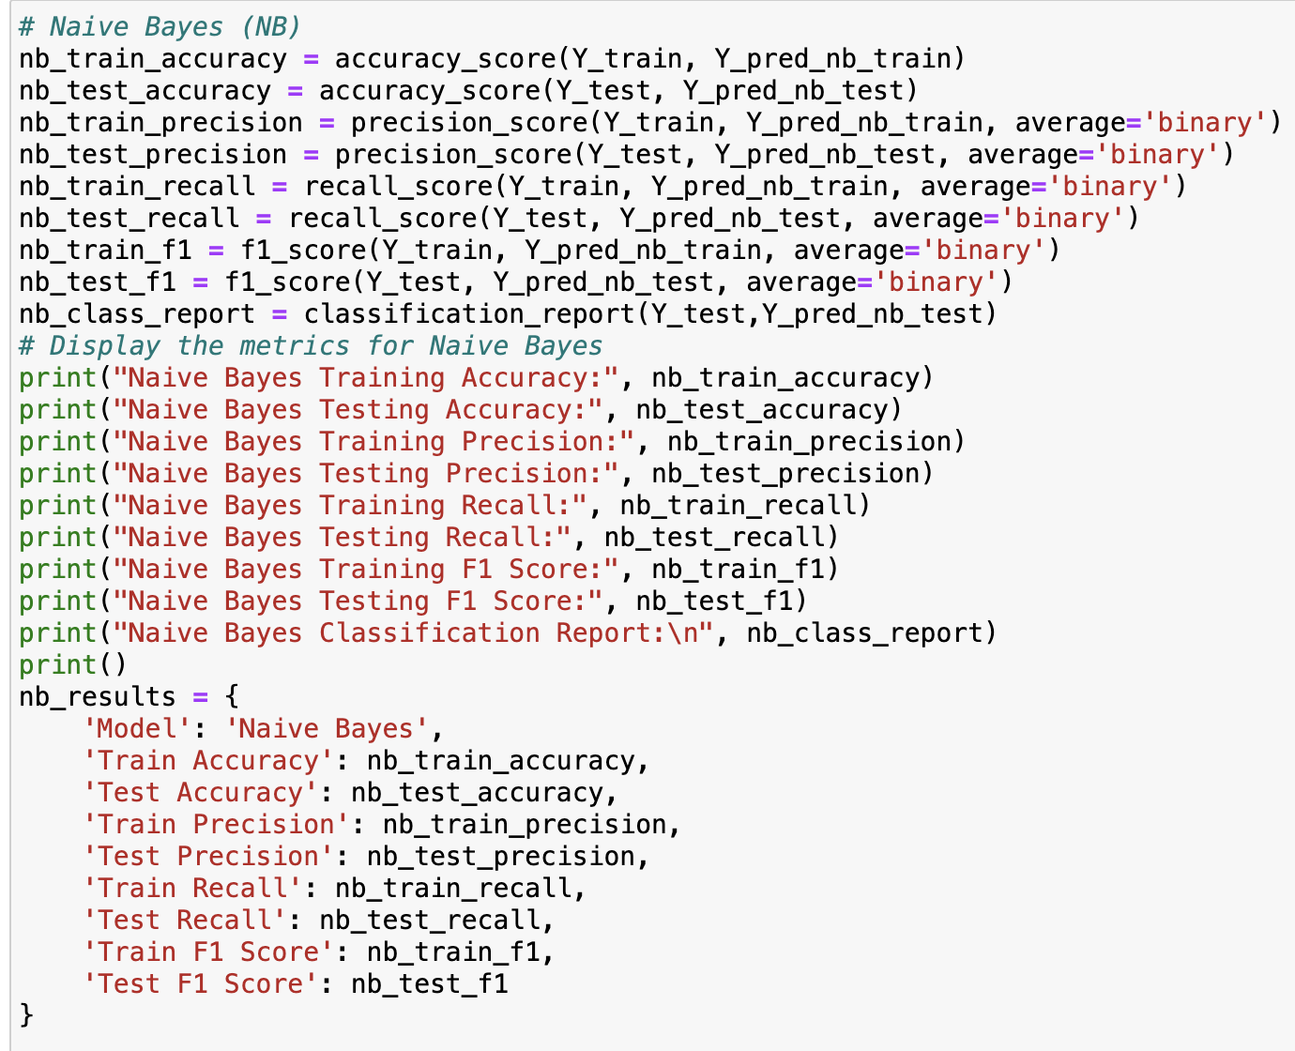

Result:

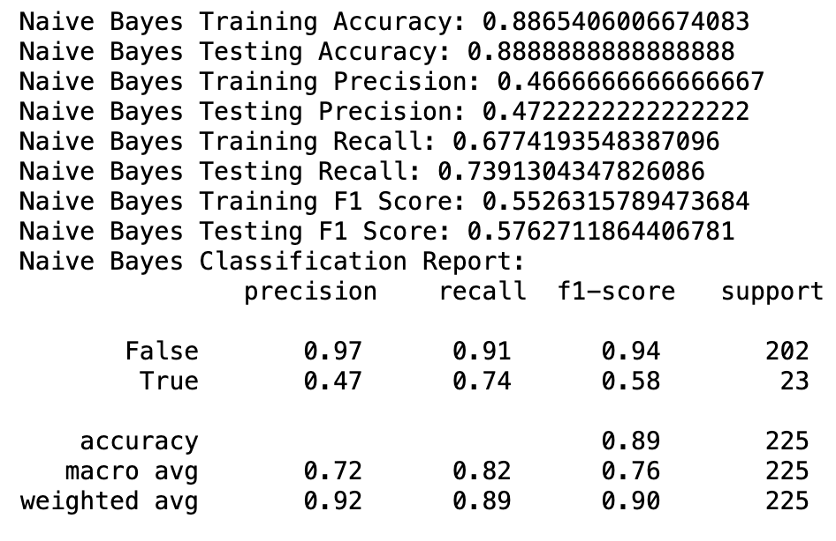

For the Decision Tree we obtained a very high accuracy In training and testing a very high training accuracy and medium testing accuracy a perfect recall for training and a high recall for testing, a very high training f1 score and a high testing f1 score.

Code:

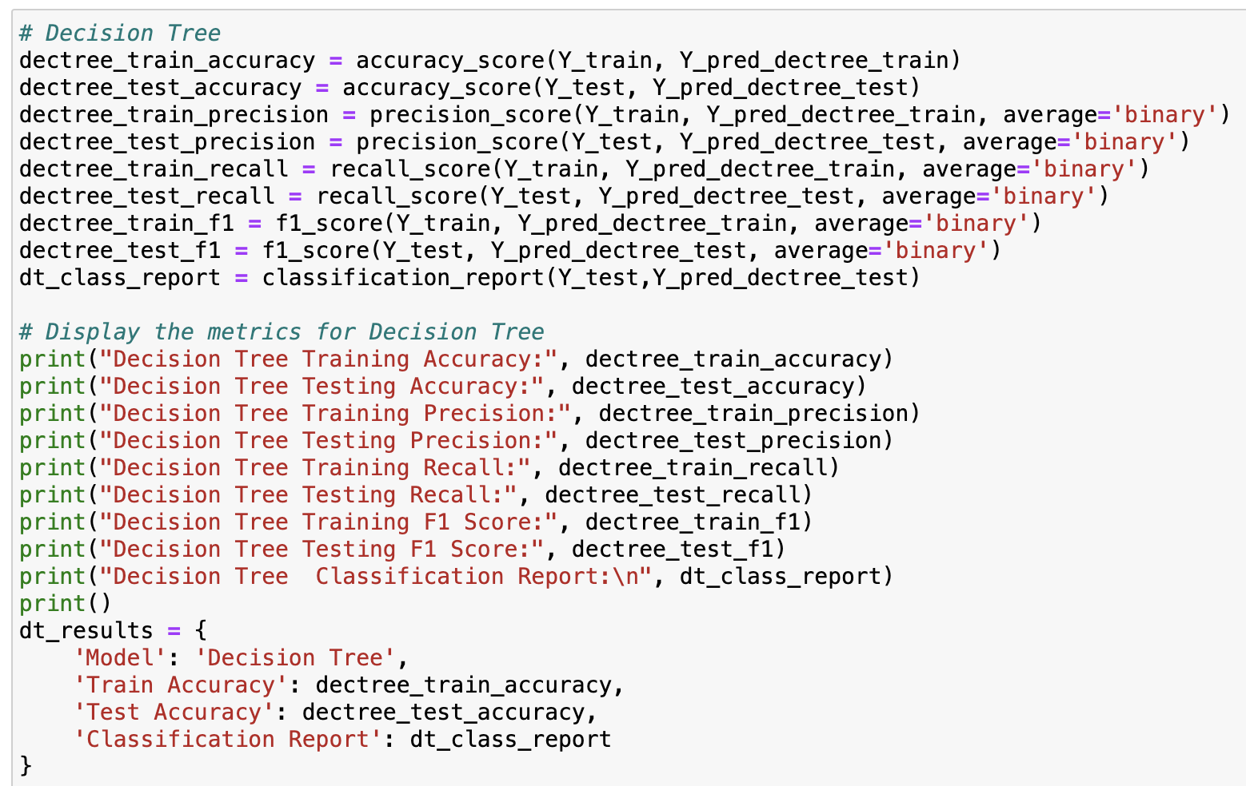

Result:

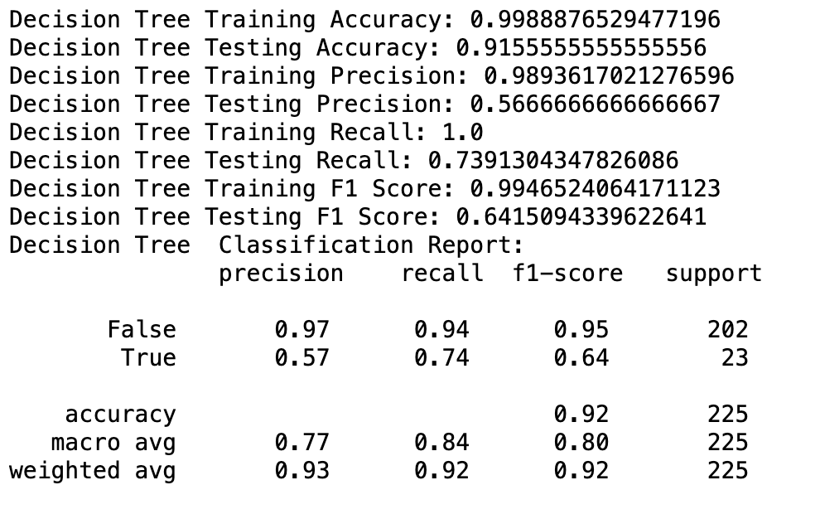

For the Random Forest we obtained very high accuracy in training and testing, a very high training precision but a rather high testing precision, an extremely high training recall but a high testing recall, an almost prefect training f1 score and a high testing f1 score.

Code:

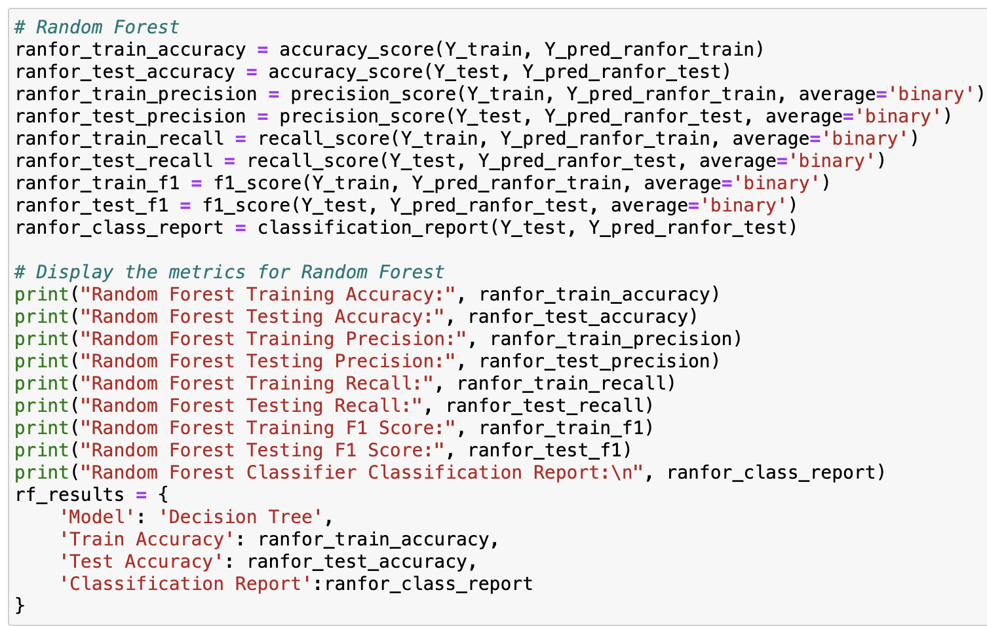

Result:

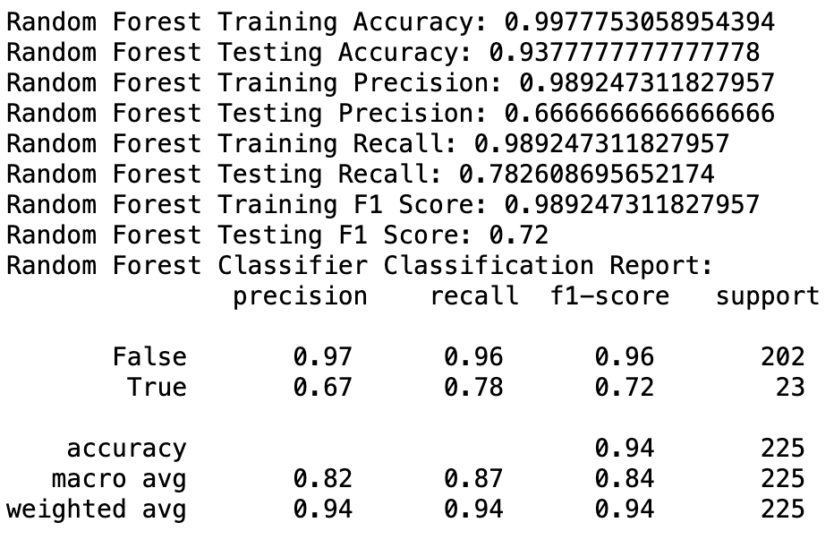

Finally for the Support Vector Classifier, we got very high accuracy in both training and testing, a high training precision and a perfect testing precision, but very low recall and f1 score for both.

Code:

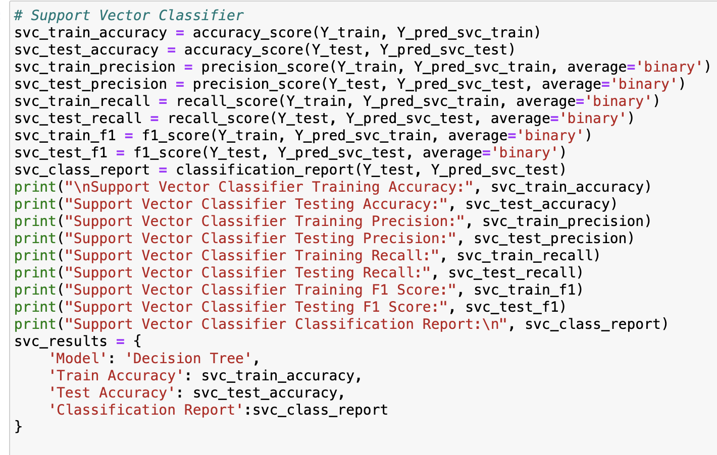

Result:

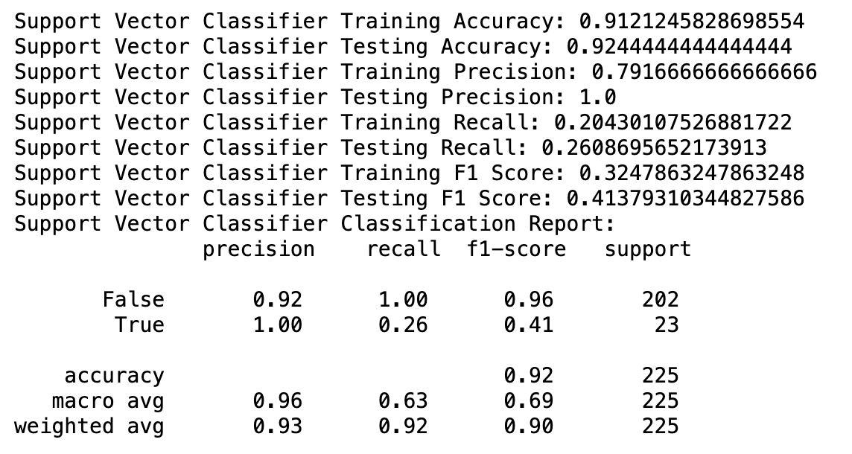

We created finally data frames for each of our 6 models and added results of each model in it removing NaN and duplicate values and padding each model to maximum length. After exiting the loop we sorted data frames based on testing accuracy and we displayed the table using tabulate function.

Code :

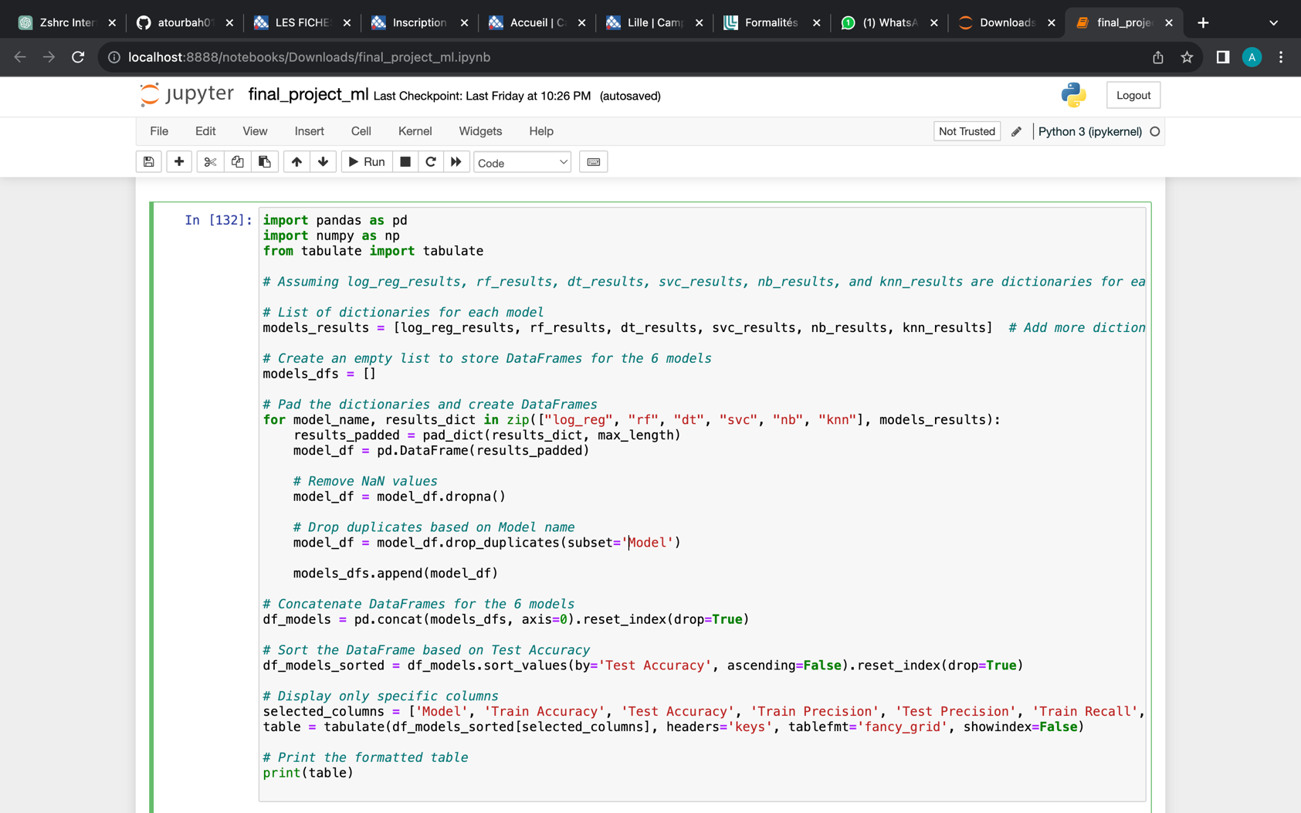

Result:

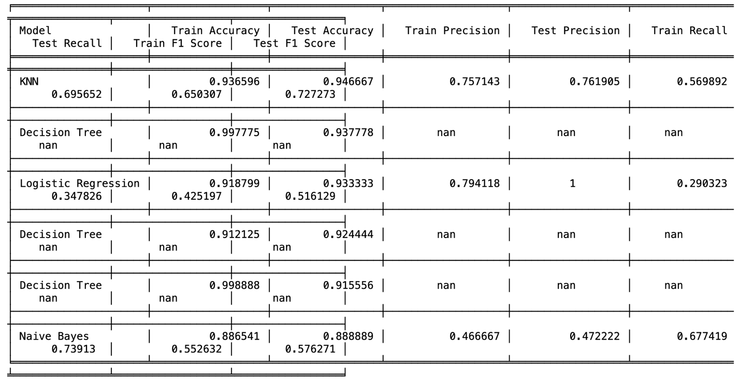

Next the confusion matrix is used to calculate a machine learning model's predictions. The confusion matrix is a table that describes the performance of a classification algorithm. It consists of four main metrics: true positives (TP), true negatives (TN), false positives (FP), and false negatives (FN). These metrics are arranged in a 2x2 matrix used by importing sklearn.metrics to allow calculations. The results shows a distinguished extremely high instance predictions of True Negative.

Code & Result:

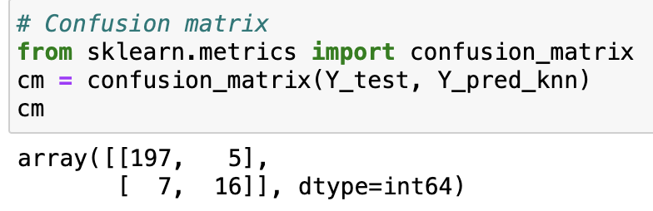

The results of the confusion matrix that we got are then analysed using heatmap.

Code & Result:

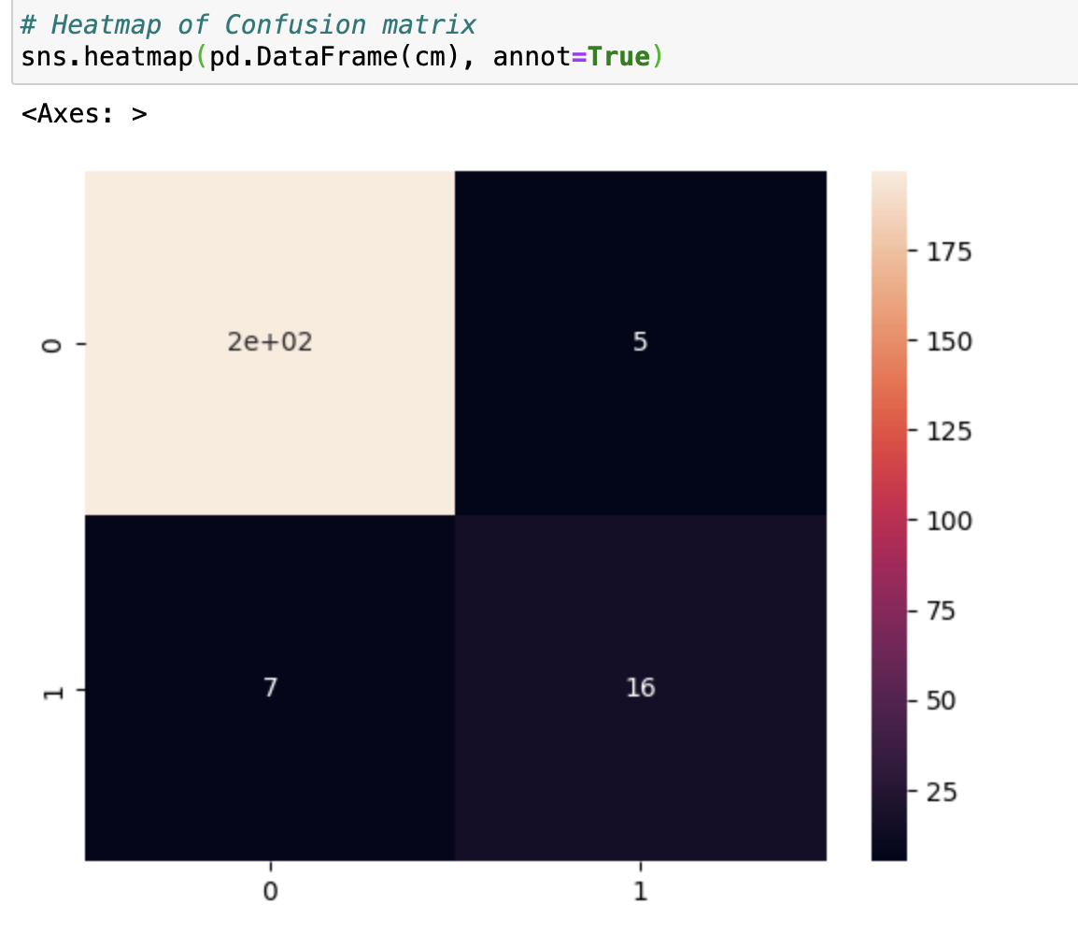

1. Performance Tuning

We used two methods for performance tuning which are grid search and random search.

For grid search method, we imported plot, KNN and grid search libraries, created KNN model, specified a grid of hyperparameters to search over including the number of neighbors (n_neighbors), the distance metric (metric) and the power parameter for the Minkowski distance (p). Then we created a GridSearchCV object with the K-nearest neighbors model, the hyperparameter grid, accuracy as the scoring metric and the 6-fold cross-validation (cv=6) by refitting the best estimator. We trained our model by Fitting the GridSearchCV object on the training data to search for the best combination of hyperparameters. We retrieved after that best paramerter and estimator from grid search to use them to make predictions on test set X.

Code:

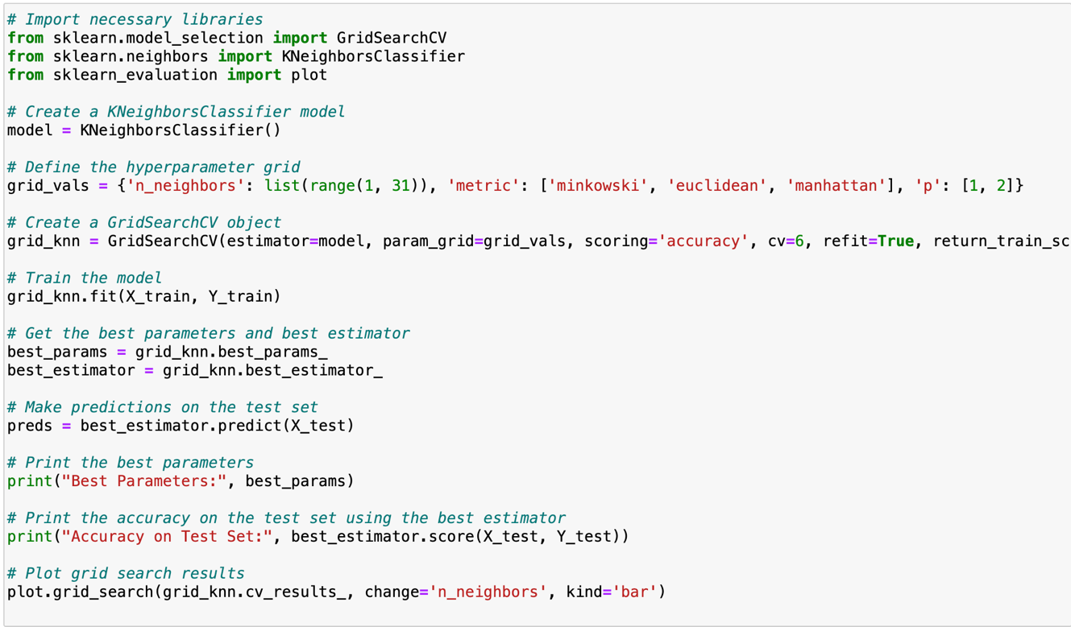

Results:

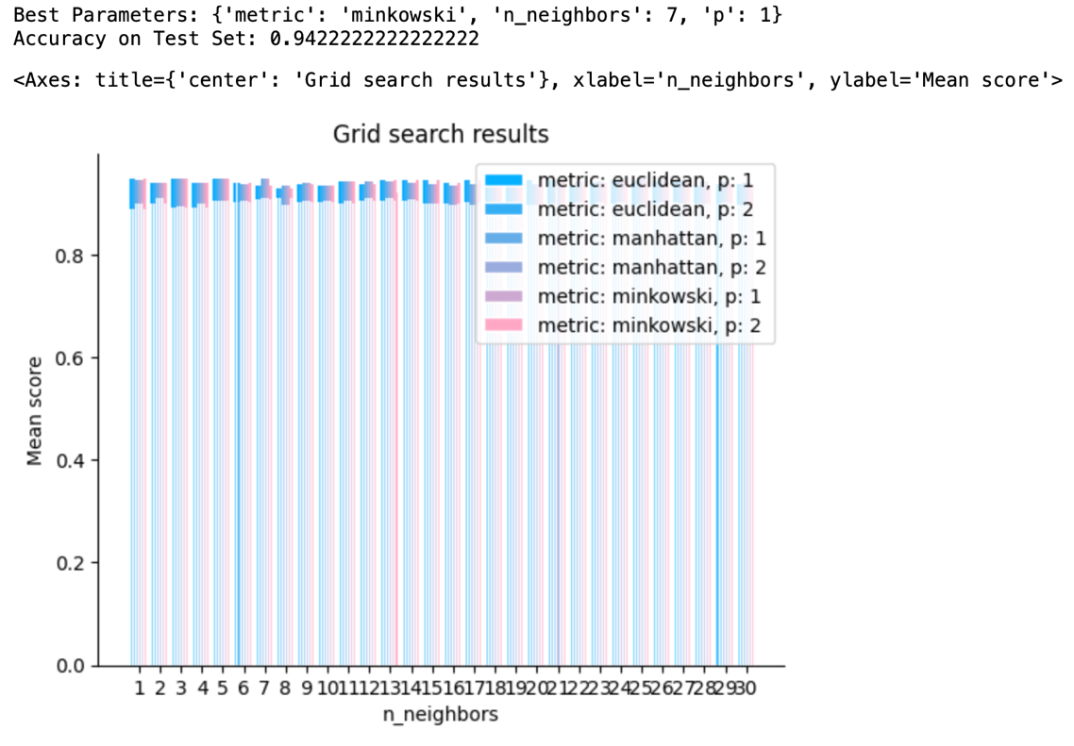

Now we performed hyperparameter tuning and model evaluation for multiple machine learning algorithms. For Random Forest, we used RandomForestClassifier from scikit-learn and defined a grid of hyperparameters (n_estimators and criterion). For Decision Tree, we used DecisionTreeClassifier from scikit-learn and we defined a grid of hyperparameters (criterion, splitter, and max_depth). For Naïve Bayes, we used GaussianNB from scikit-learn however it doesn’t have hyperparameters to tune. For Logistic Regression, we used the functionLogisticRegression from scikit-learn and defined a grid of hyperparameters (penalty and C). For Support Vector Classifier, we used SVC from scikit-learn and define a grid of hyperparameters (kernel and C). In addition for each algorithm, we performed a grid search using GridSearchCV and fitted the model, obtained the best hyperparameters and evaluatd on the test set except Naïve Bayes because it doesn’t have hyperparameters. The code systematically explores different hyperparameter combinations for each model to find the configuration that yields the highest accuracy.

Code:

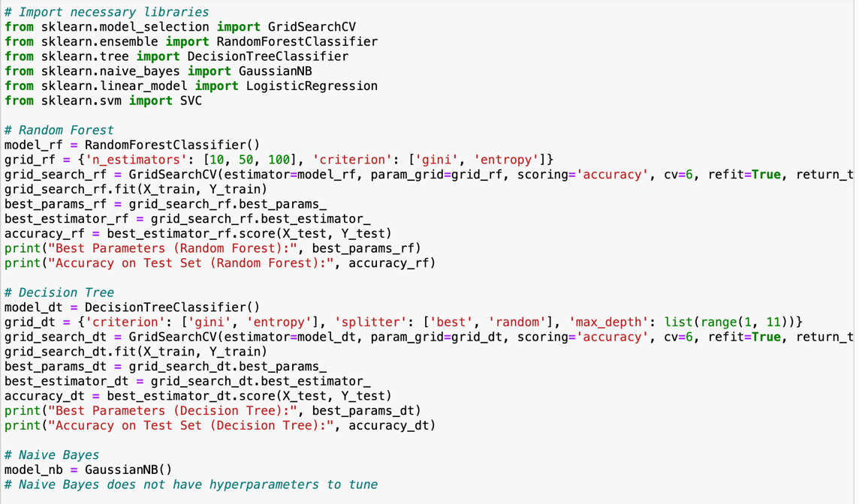

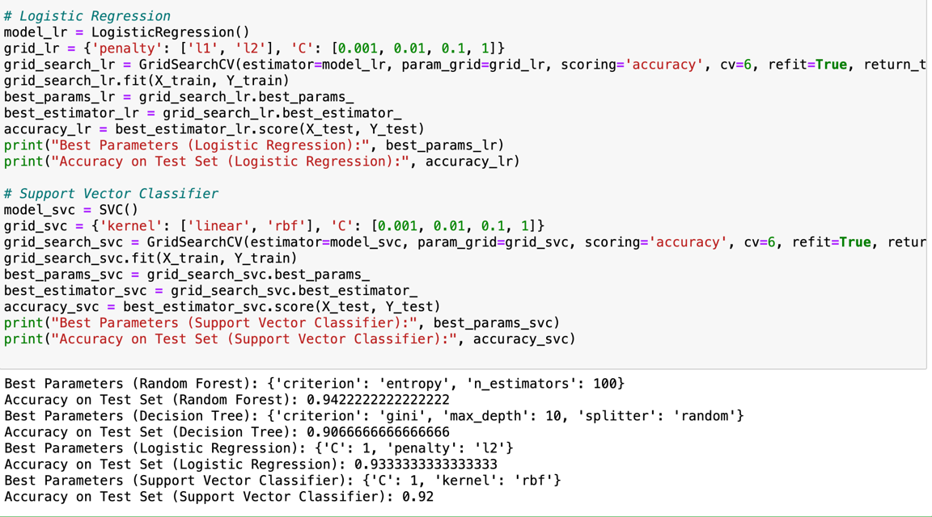

Results:

The accuracy is extremely high on each model.

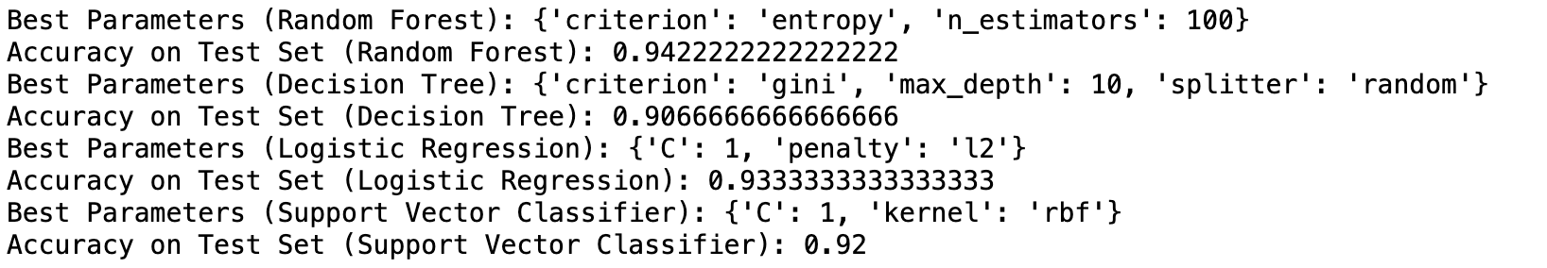

Then we generated bar plots for visualization of our results on each model by creating a bar plot displaying the mean test scores for different hyperparameter combinations, an X-axis which is the index of parameter combinations, a Y-axis which is the mean test score for each combination and a title for each algorithm.

Code:

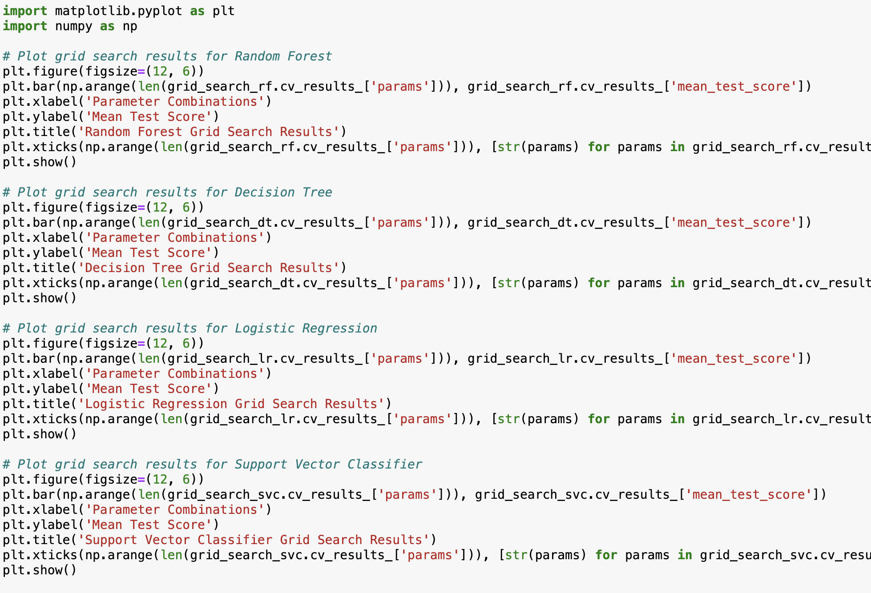

Results:

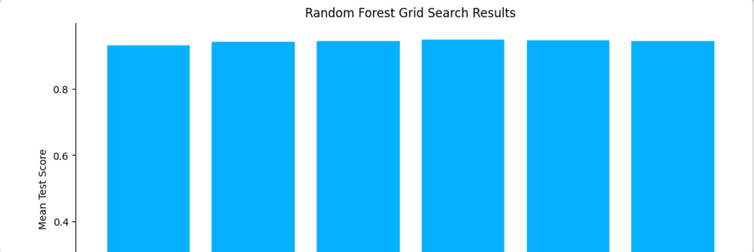

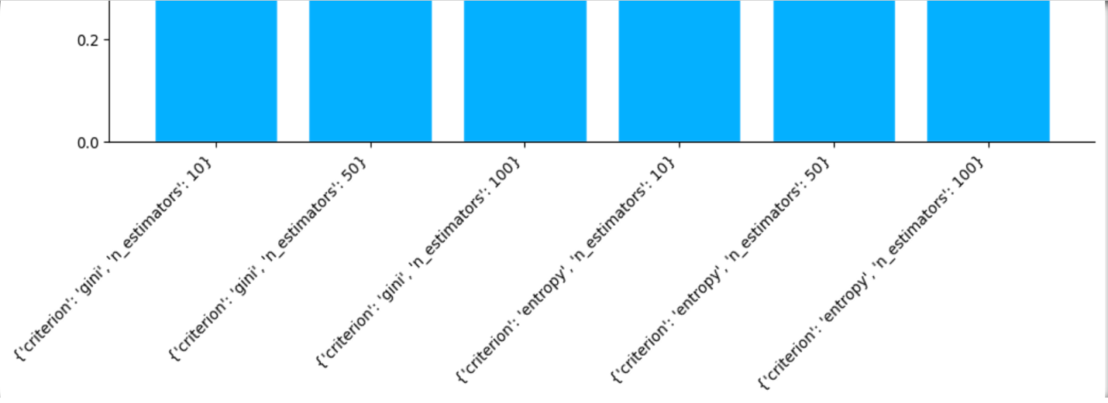

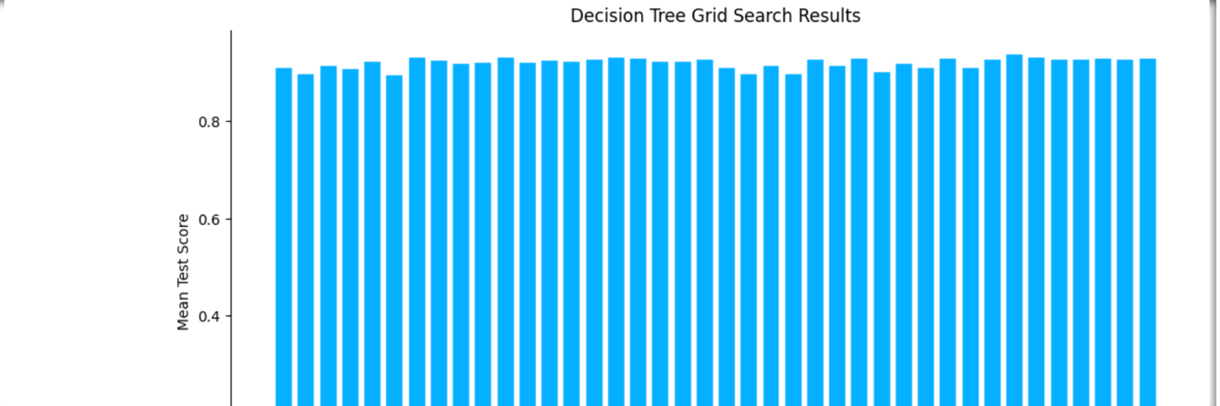

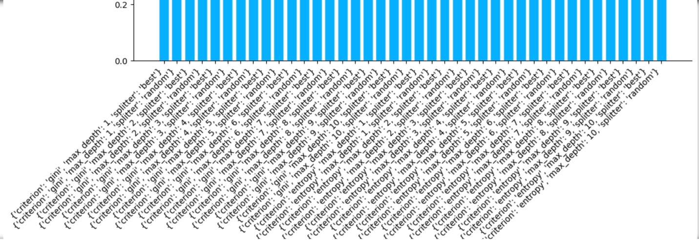

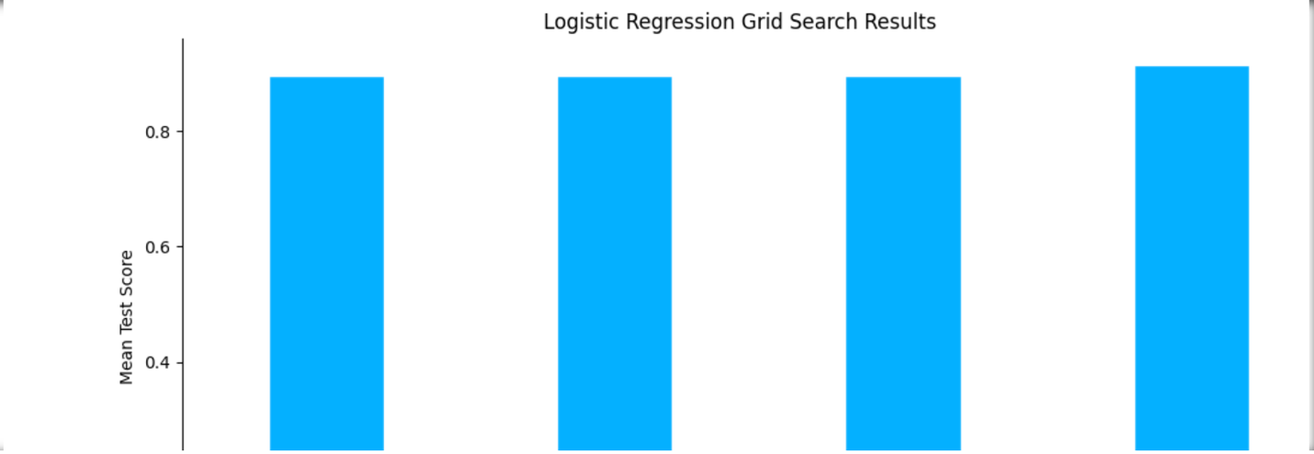

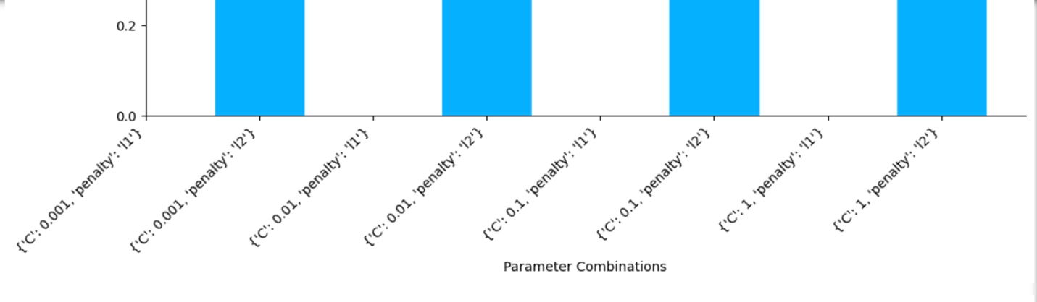

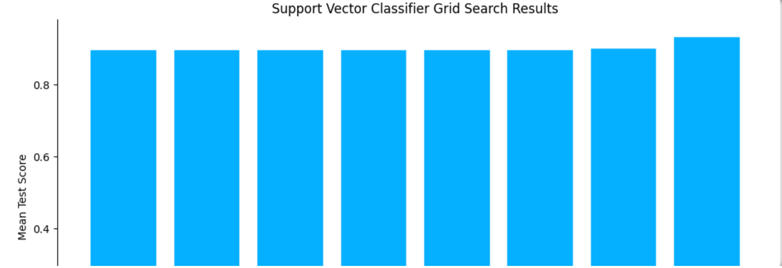

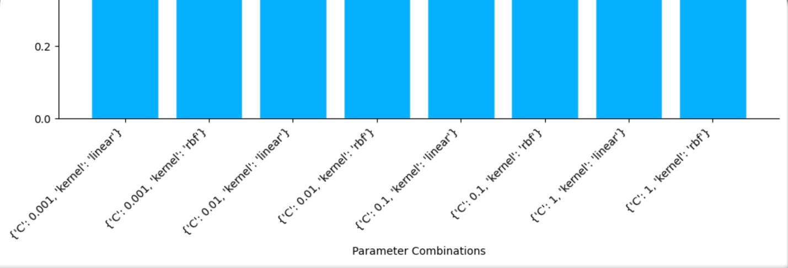

They are almost all equal for random forest and decision tree and logistic regression except svc.

The next step performs hyperparameter tuning using randomized search for several machine learning models and visualizes the results. For each algorithm, we create their specific function method model and defines a hyperparameter grid and use RandomizedSearchCV to search for the best hyperparameters and print and stores the best parameters and accuracy on the test set for each model. We finally plot the results and conclude the higher the C the better the mean is.

Code:

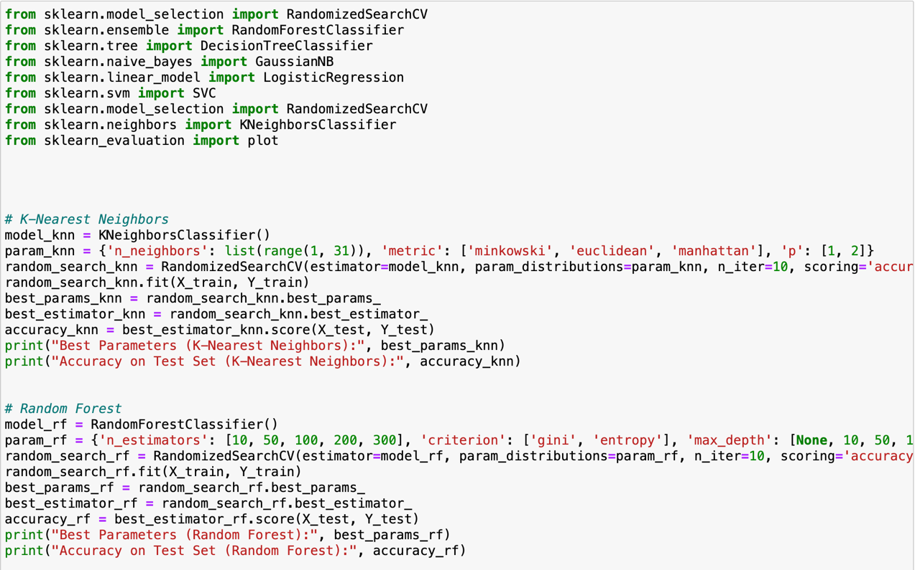

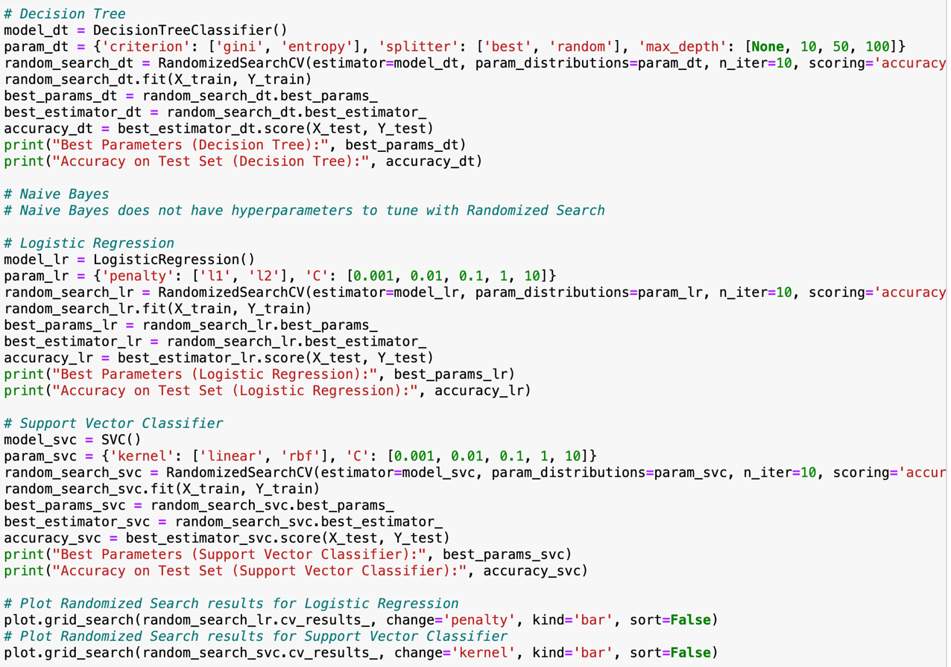

Results:

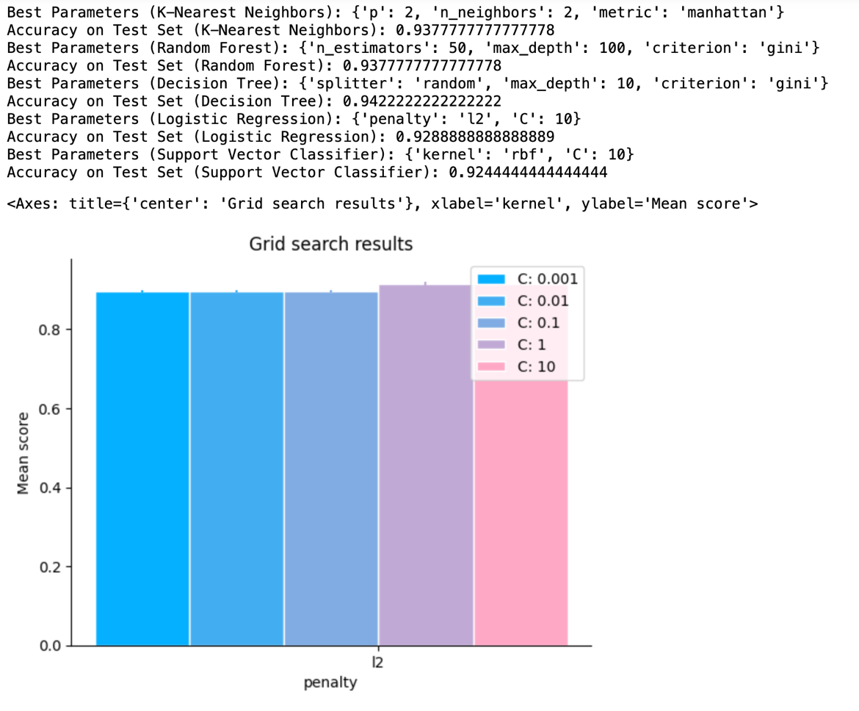

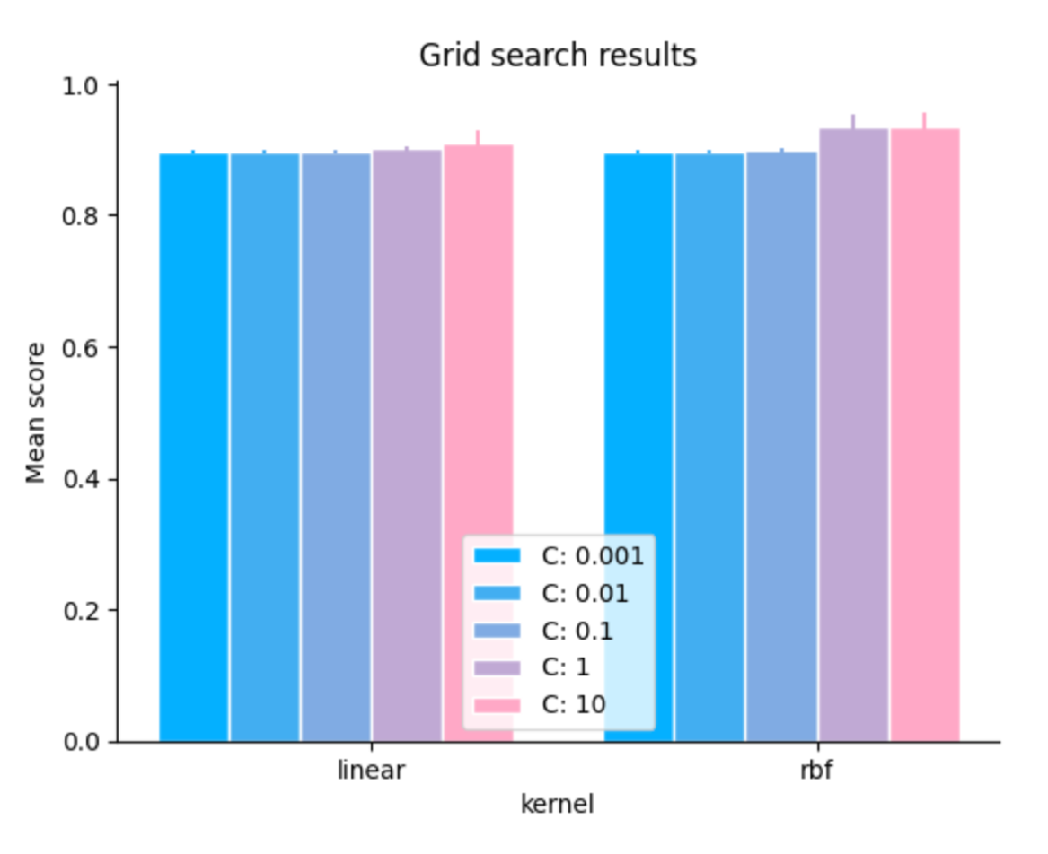

We then performed randomized search on each model of the 3 (KNN, Random Forest and Decision Tree) by extracting data (x axis for specific for each algorithm different and y axis being the mean) and plotting them using plot bar to compare and analyze our results with yerr being the error bars (black color) representing standard deviation of the test score.

Codes & Results:

KNN:

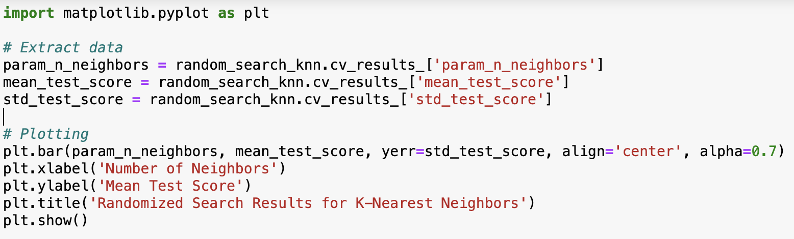

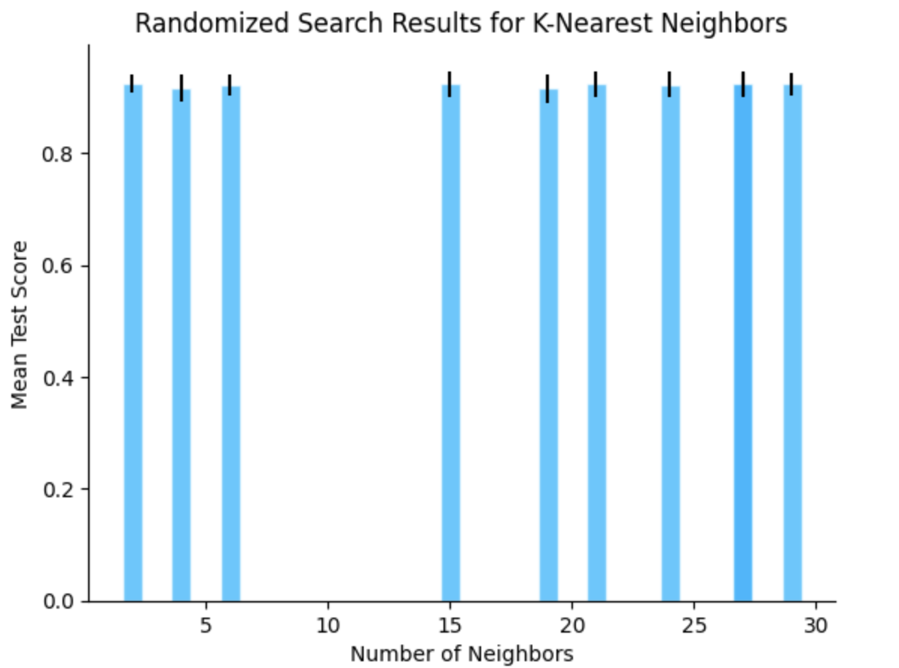

Random Forest:

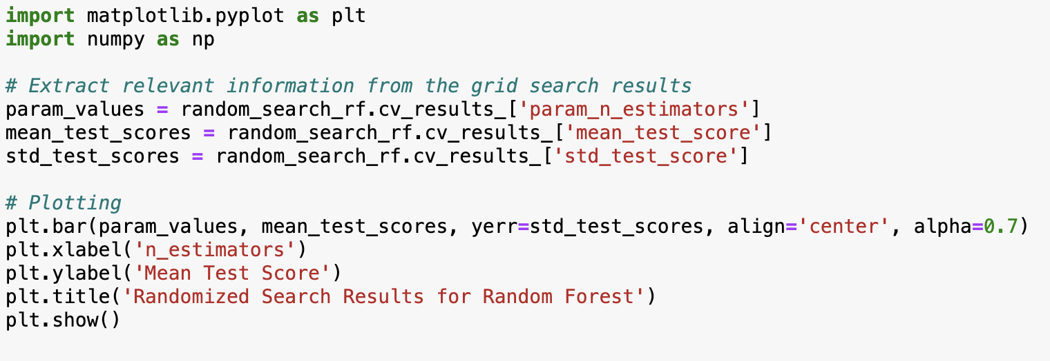

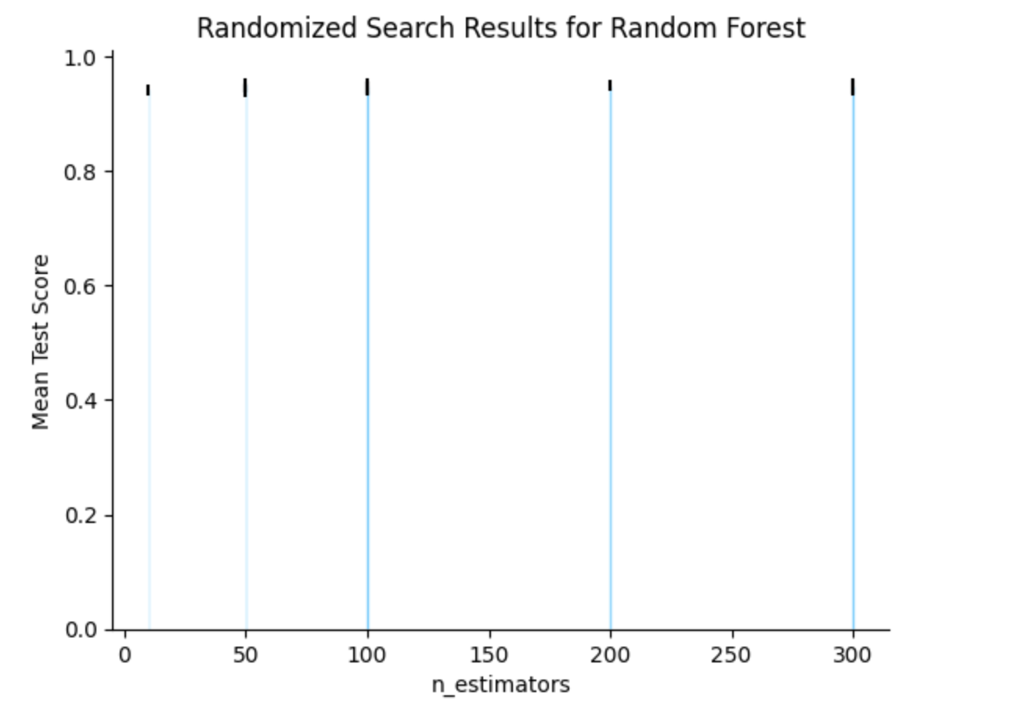

Decision Tree:

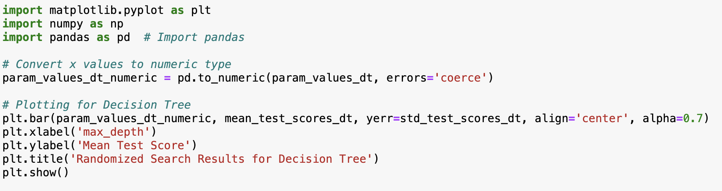

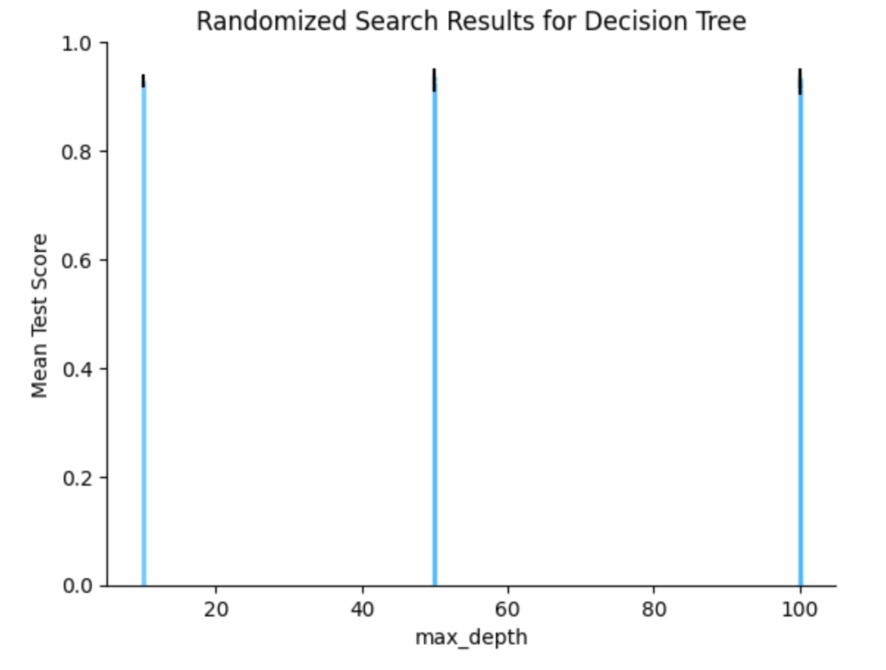

1. Prediction Making

To predict the Pokémon if it is legendary or not, we decided to go with logistic Regression since it gave us above 90% accuracy in training and testing as well as a prefect testing precision. As for the methods used we used single and multiple class predictions. For both implementations we generated a 2d classification dataset using make blobs generated 1 random state 2 centers 2 number of features and 100 number of sample and we fit them in the Logistic Regression function to generate new instance for the multiple class we created X new using make blobs to make predictions and predicted Y new from the X new and displayed the results in the for loop. As for the single class prediction the difference is with the X new where we put fixed range for X new and started prediction for Y and displayed instead of using make blobs function.

Code & Results:

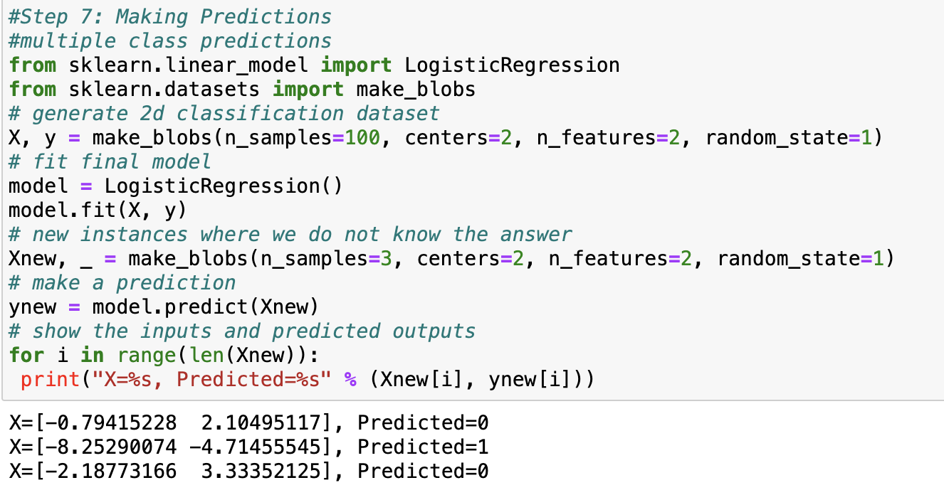

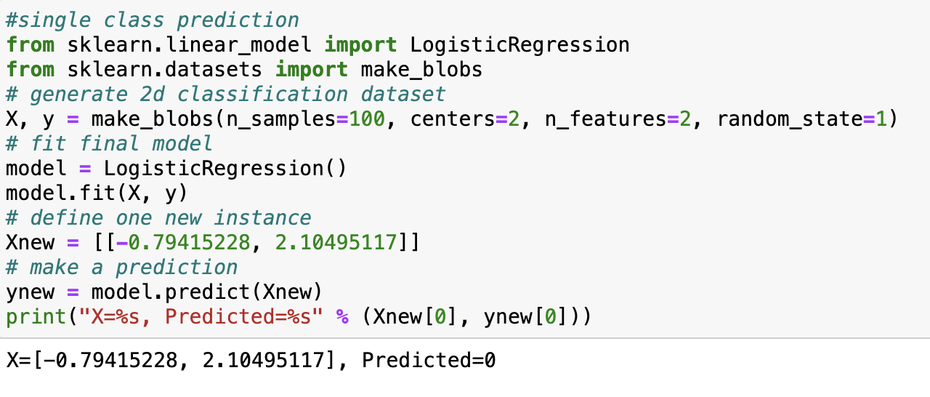

Conclusion:

Finally, the project demonstrated the feasibility of using machine learning for predicting Pokémon types. The choice of the most suitable algorithm depends on factors such as dataset characteristics and the desired balance between precision and recall. We gained insights from the project that could be valuable for understanding the relationships between Pokémon attributes and types. In summary, the Pokémon machine learning project provides a comprehensive exploration of classification techniques, offering valuable insights into the potential applications of machine learning in the context of Pokémon attributes and types. However, further refinements and explorations could enhance the predictive capabilities of the models for future analyses.